**EXPERIMENT-1**

**Aim:** To explore BioModels database- a repository of mathematical models of biological /biomedical Systems.

**Theory**

**BioModels Database- Definition**

BioModels Database is a repository of computational models of biological processes. It hosts models described in peer-reviewed scientific literature and models generated automatically from pathway resources (Path2Models). A large number of models collected from literature are manually curated and semantically enriched with cross-references from external data resources (such as publications, databases of compounds and pathways, ontologies, etc.). The resource allows scientific community to store, search and retrieve mathematical models of their interest. In addition, features such as generation of sub-models, online simulation, conversion of models into different representational formats, and programmatic access via web services, are provided.

Users can browse and search the content of the repository, and download models in SBML format, as well as various other formats, such as XPP, VCML, SciLab, Octave, BioPAX, PNG, SVG, ... A human readable summary of each model is also available in PDF.

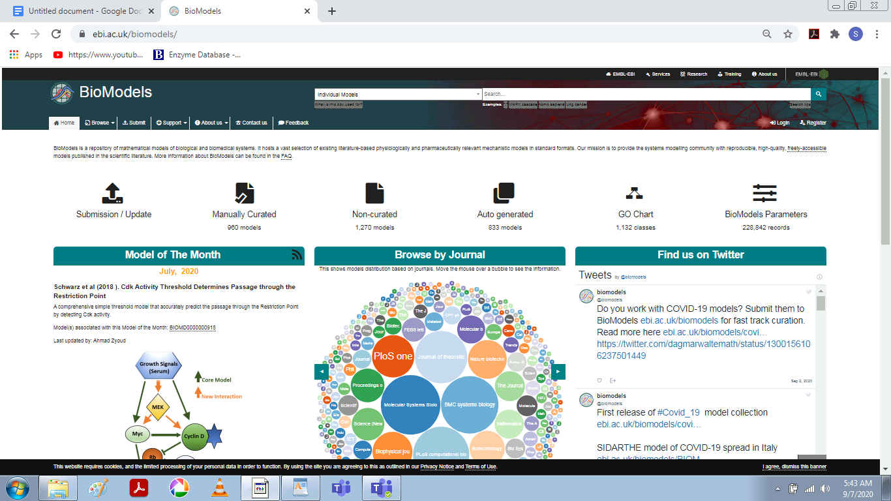

**Difference between BioModels database and other model database**

BioModels Database is more than just a repository of models, it is a true database. The models, their controlled annotation and all related information is stored in a set of MySQL tables. This allows users to search not only for particular models based on their internal components elements, but also based on the extensive additional annotation. In addition, this annotation allows the exploration of the relevant linked resources, thereby facilitating the understanding of the concepts upon which the model is founded.

**Difference between BioModels Database and biological pathway database**

BioModels Database is not a database of biochemical pathways. The current state of the field of Computational Systems Biology means that these models are largely dominating the resource at the moment, but the scope of BioModels Database itself is larger than just biochemical events. A quantitative model also differs from a pathway in several respects:

A pathway need not contain quantitative information on the amount of objects, their behaviour, nor on their location.

A pathway is static, while a model can be instantiated into dynamic simulations.

A formal model can merge several biochemical reactions into one, or conversely, can contain reactions without counterparts in the corresponding biological context. The purpose is that the simulations performed with the model produce quantitative results commensurate with the available experimental knowledge.

**Difference between BioModels Database and Reactome**

Reactome is a database of reactions and pathways, not a database of quantitative models. The SBML files exported by Reactome (or KEGG for that matter) do not contain any quantitative information, whether quantities (amount or concentration of species) or kinetics. Reactome aims to describe the human cellular pathways accurately and in great details, not to distribute abstract quantitative description of their functions.

**MIRIAM guidelines**

MIRIAM is the Minimum Information Required in the Annotation of Models (publication and press Release). Initiated by the BioModels.net project, it is a set of guidelines defining how a model should be encoded and annotated in order to be successfully distributed, exchanged and ultimately reused.

In particular MIRIAM requires that a model provides all the information necessary to instantiated in a simulation, such as the initial conditions. In addition, the reaction graph generated from this simulation must reproduce the results of the original publication, in which the model was first described. Moreover, the MIRIAM guidelines require that all model components contain sufficient controlled annotation such that each component can be unambiguously identified. The MIRIAM Registry and Identifiers.org have been developed specifically to provide generation and resolution services for unique and perennial identifiers to be used in controlled annotations.

All models stored in the curated branch of BioModels Database are MIRIAM-compliant.

All the models in the curated branch are fully MIRIAM compliant. Each of the MIRIAM requirements is satisfied in the following way:

**Models are encoded in a public standard format**-All models in BioModels Database are converted into valid SBML.

**Models must be clearly related to a single reference**-Each model is derived from a scientific publication.

**The model must correspond to the biological processes represented in the publication**-Models are manually checked to confirm accurate biological representation in the model.

**The simulation results generated from the model must reflect those in the reference publication**-Models are manually checked to confirm accurate simulation results are generated from the model. The result of this step is available in the "Curation" tab.

**External data resources annotation**-Models elements are well annotated.

Model elements can describe a plethora of different entities, such as genes, proteins or metabolites. The usage of free text or non-standard nomenclature to identify those elements is not reliable, as it can introduce ambiguity to the model components, such that subsequent users of a model would struggle to identify the precise entities involved.

Annotation is useful to identify model elements. This ensures that users will be able to understand the models and increases the possibility of their reuse. Moreover, annotation is a key element for processes such as data comparison, data integration and data conversion. Finally, this also allows provision of accurate search engines (BioModels Database makes heavy use of annotation when users search for models of interest).

Models in BioModels Database are provided with consistent annotation using unambiguous identifiers. Those identifiers are generated by the MIRIAM Registry and Identifiers.org services. They can be used to reference records from external databases (such as Taxonomy, EMBL-Bank or UniProt), terms from ontologies (such as Gene Ontology, SBO or ChEBI), publications, etc.

**Annotations stored in SBML files of the models**

The annotation of each model component is stored in the corresponding SBML element using the a scheme initially designed by Nicolas Le Novère and Andrew Finney, and now part of SBML (since Level 2 Version 2). It relies on the use of RDF, Dublin Core, vCard and the BioModels.net qualifiers.

Tools used by the curators of BioModels Database

Our curators use a wide range of tools to perform their curation tasks: CellDesigner, COPASI, Jarnac, MathSBML, RoadRunner, SBMLOdeSolver, SBMLeditor, SemanticSBML, JigCell, XPP-Aut, ..

**PROCEDURE**

To explore Hodgkin-Huxley 1952 squid-axon (BIOMD0000000020)

Ways to browse and search BioModels Database

There are two main ways in which the BioModels Database can be browsed:

There are two options available on the left side of the home page namely Recently published models and Recently accessed models which provides better browsing options.

To search a model, there is a search option available on the top right hand side of the home page.

There are enhanced search options available on the left side of the browse page namely the models curation status, the model format, the modelling approach, model flag, the organism, disease, GO, and the UNIPROT model.

**Ways to Download a model from BioModels Database-**

There are several ways to download the models:

Each model can be downloaded from its own description page, via a "Download " option present at the top menu by clicking on the checkbox of the model we want to download.

Then by clicking on the “Files” option, you can choose the format of the file you want to download it.

Under the History option, you can even choose the version of the model you want to download depending on the revisions.

**Aim**- To explore BioModels database and retrieve one each for five organisms namely- Homo sapiens, Eukaryotes, Bacteria, Yeast and one for cancer.

Tool Used- BioModels Database from EMBL- EBI

URL- https://www.ebi.ac.uk/biomodels

**FOR HOMO SAPIENS:-**

Model Name- Hancioglu2007-Human Immune Response to Influenza A virus infection

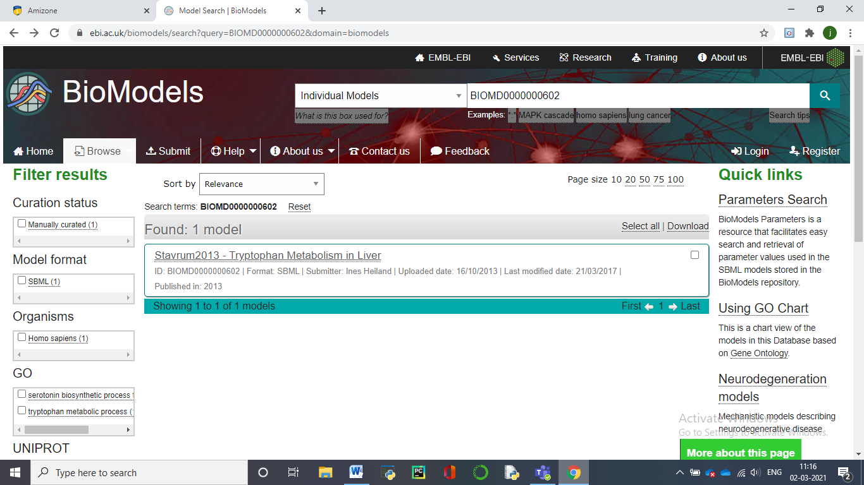

Model Identifier-BIOMD0000000602

Given By- Ines Heiland

Short Description- We present a simplified model of Stavrum2013 - Tryptophan Metabolism in Liver. Tryptophan is utilized in various metabolic routes including protein synthesis, serotonin, and melatonin synthesis and the kynurenine pathway. Perturbations in these pathways have been associated with neurodegenerative diseases and cancer. Here we present a comprehensive kinetic model of the complex network of human tryptophan metabolism based upon existing kinetic data for all enzymatic conversions and transporters. By integrating tissue-specific expression data, modeling tryptophan metabolism in liver and brain returned intermediate metabolite concentrations in the physiological range. Sensitivity and metabolic control analyses identified expected key enzymes to govern fluxes in the branches of the network.

Format- SBML(L2V4) as shown below:-

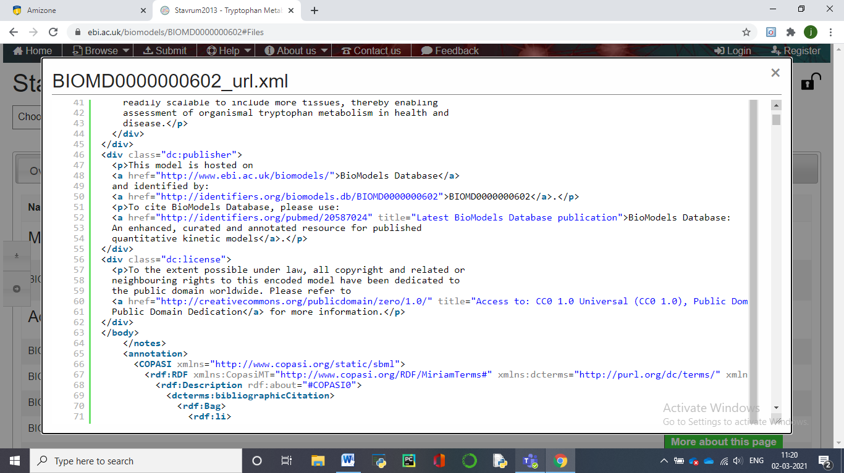

Curation status- Manually curated as shown:-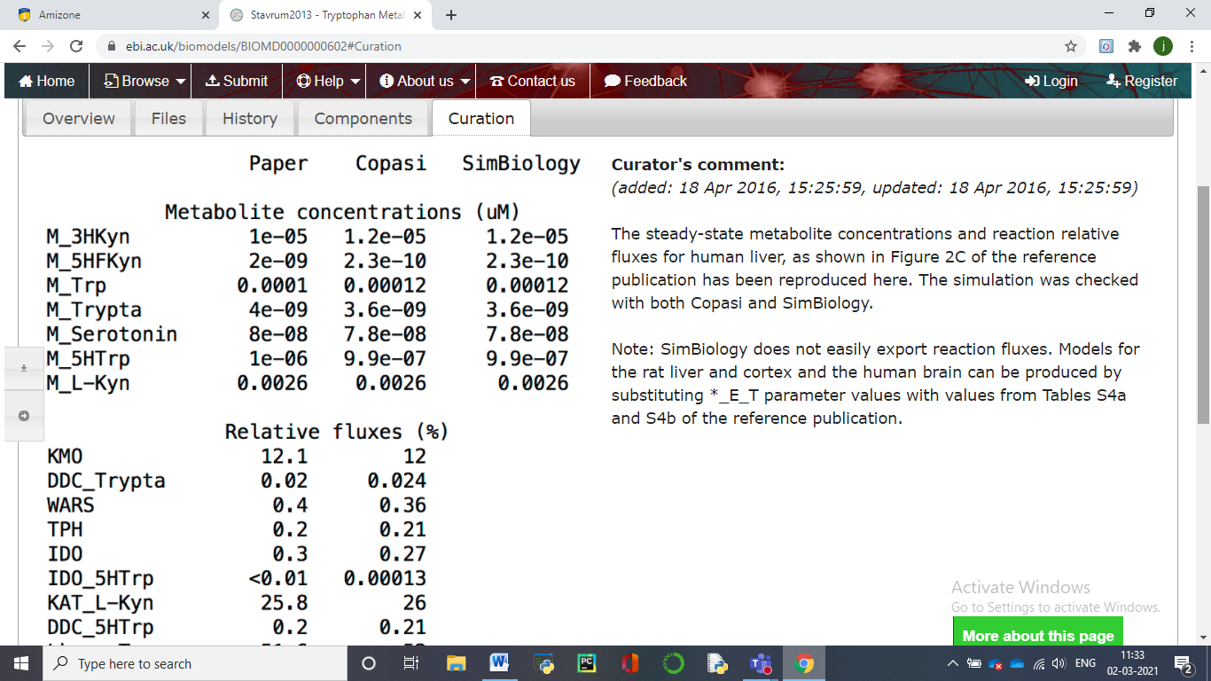

Number of species- 11

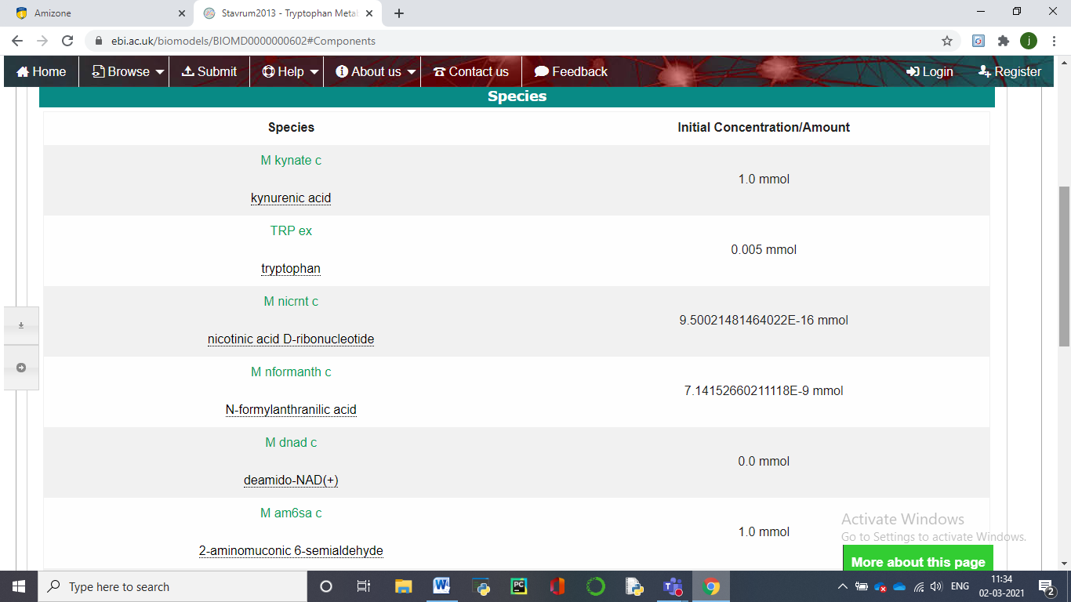Number of reactions- 10

**B) FOR EUKARYOTES-**

Model Name- Firczuk2013-Eukaryotic mRNA translation machinery

Model Identifier- BIOMD0000000457

Given By- Szeyi Ng on 05-Sep-2019

Short description- Firczuk2013 - Eukaryotic mRNA translation machineryThis is a model of *Saccharomyces cerevisiae* mRNA translation which includes the initiation, elongation and termination phases. The model is for 20 condon mRNAs. The building of a multi-factor complex in initiation and also the different processes in elongation and termination are modelled in detail. The model takes into account that ribosomes cover more than one codon of mRNA so that the movement of ribosomes are effectively blocked by other ribosomes several codons downstream. It is assumed that 15 codons are occupied by each ribosome. This blocking effect is considered in reaction R18 in initiation and also reaction R26, the reaction where translocation of ribosomes takes place in elongation. The kinetic functions of these two reactions are based on MacDonald et al. 1968 and Heinrich & Rapaport 1980. All other kinetic functions follow mass-action kinetics. The concentrations of transfer RNA species (Met-tRNA, aa-tRNA and tRNA in the model) are kept constant, while the other species' concentrations can change in the course of the simulation. The model describes the translation of a short mRNA with 20 codons. Therefore, all reactions in the elongation cycle (R22, R23, R25, R26, R28 and R29) and the corresponding species are replicated accordingly to model the species with ribosomes bound at different positions. In summary, the model contains 165 different species and 141 reactions.

Format- SBML(L2V4)

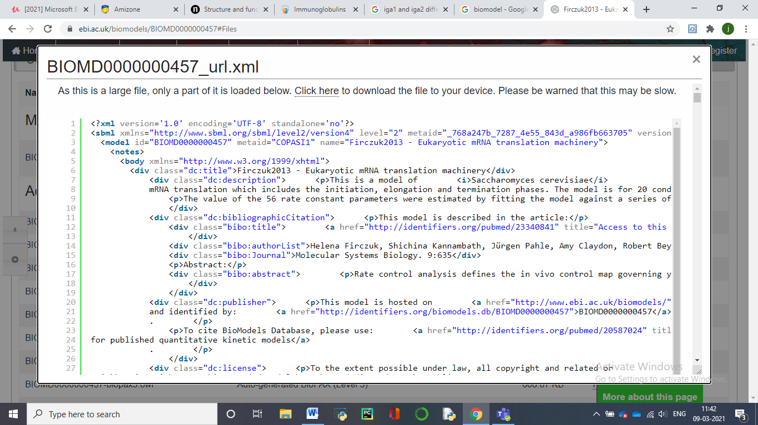

Curation status- Manually curated

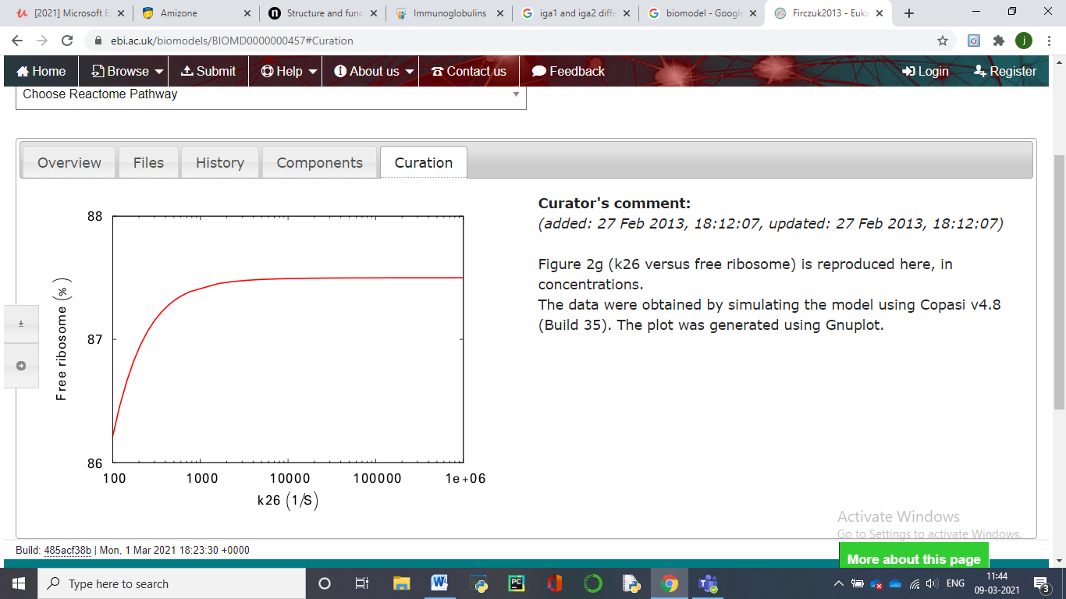

Number of species- 13

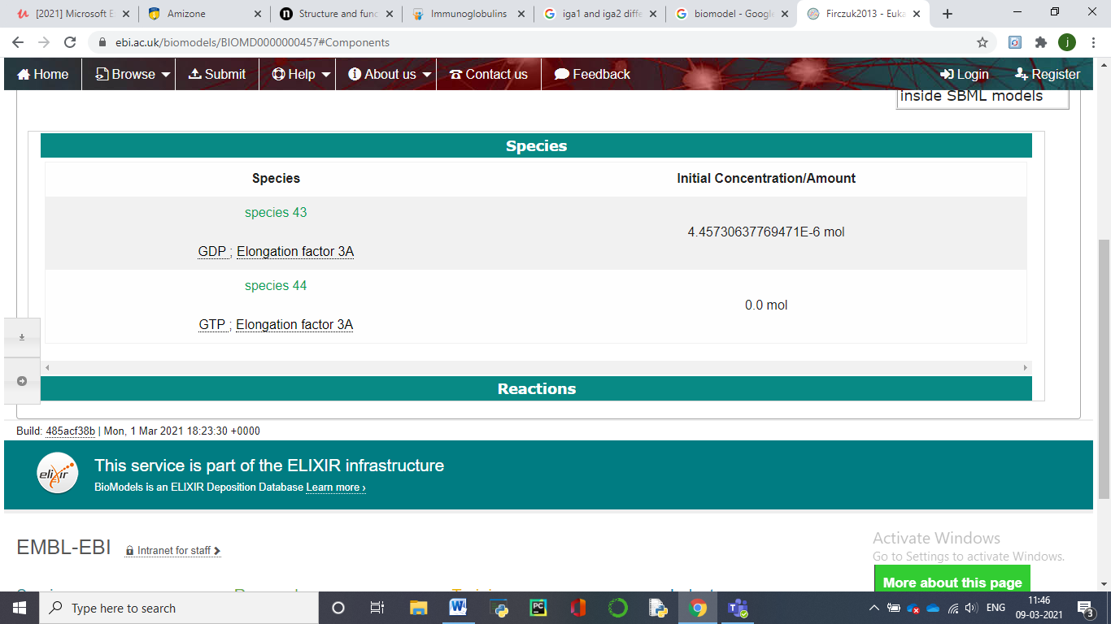

Number of reactions- 14

**C). FOR BACTERIA**

Model Name- Leber2015-Mucosal immunity and gut microbiome interaction during C difficile infection

Model Identifier- BIOMD0000000583

Given By- Andrew Leber on 20-Jul-2015

Taxon- Peptoclostridium difficile (strain 630) in Mus musculus

Short Description- The model demonstrates a crucial role of T helper 17 (Th17) effector responses in the colonic lamina propria and luminal commensal bacteria populations in the clearance of C. difficile and colonic pathology, whereas regulatory T (Treg) cells responses are associated with the recovery phase. In addition, the production of anti-microbial peptides by inflamed epithelial cells and activated neutrophils in response to C. difficile infection inhibit the re-growth of beneficial commensal bacterial species.

Format- SBML(L2V4)

Curation status- Manually curated

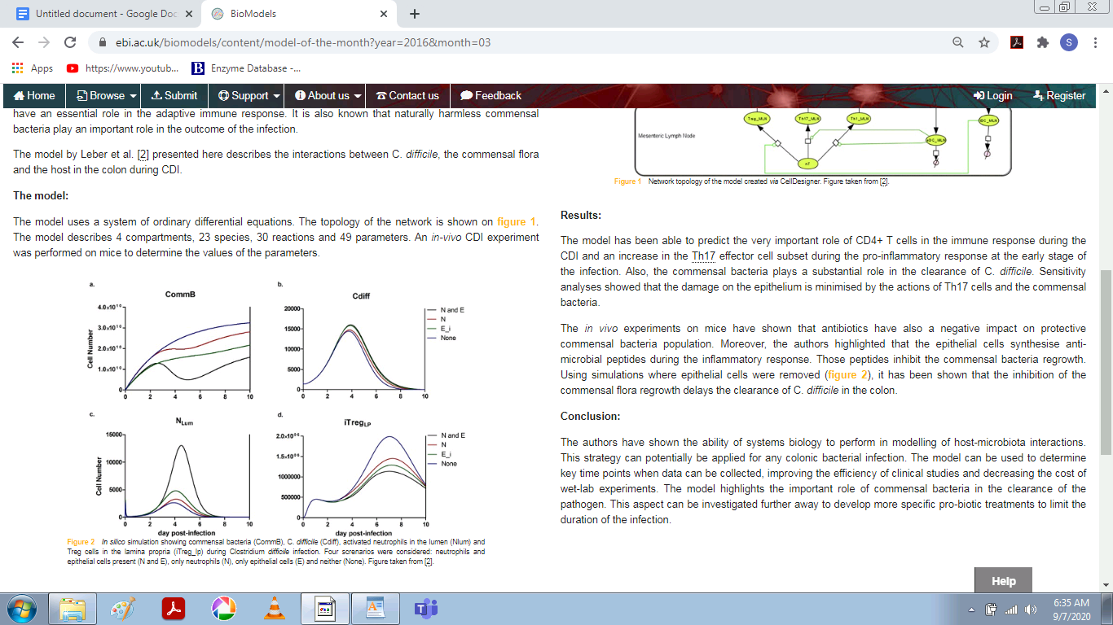

Fig- *In silico* simulation showing commensal bacteria (CommB), C. *difficile* (Cdiff), activated neutrophils in the lumen (Nlum) and Treg cells in the lamina propria (iTreg_lp) during Clostridium *difficile* infection. Four screnarios were considered: neutrophils and epithelial cells present (N and E), only neutrophils (N), only epithelial cells (E) and neither (None).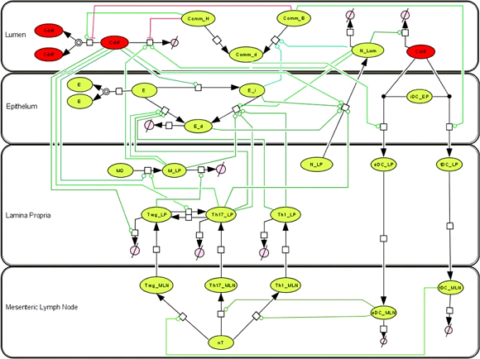Fig - Network topology of the model created *via* CellDesigner.

Number of species- 9

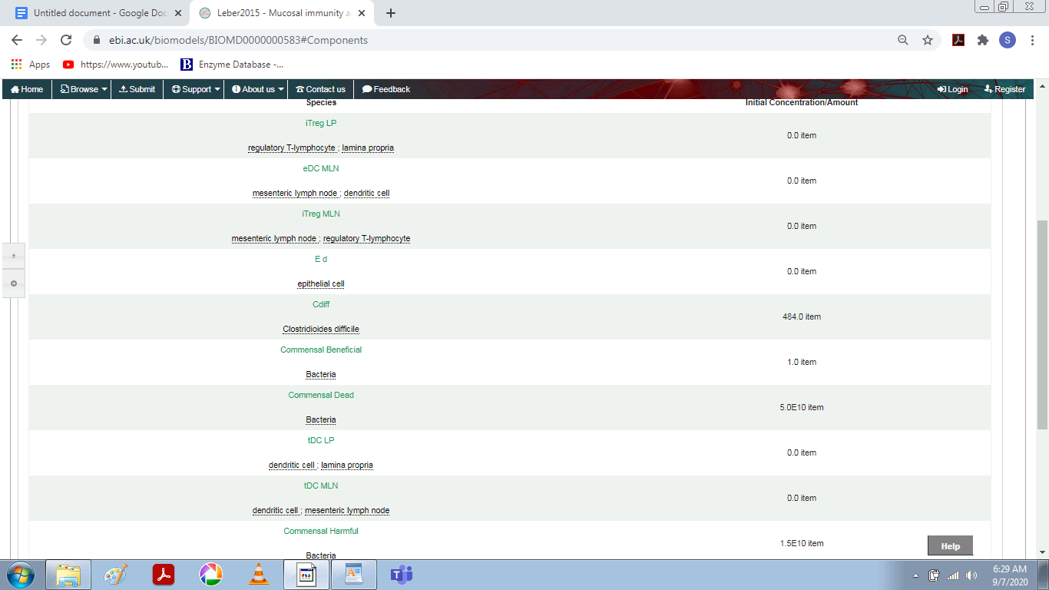

Number of reactions- 14

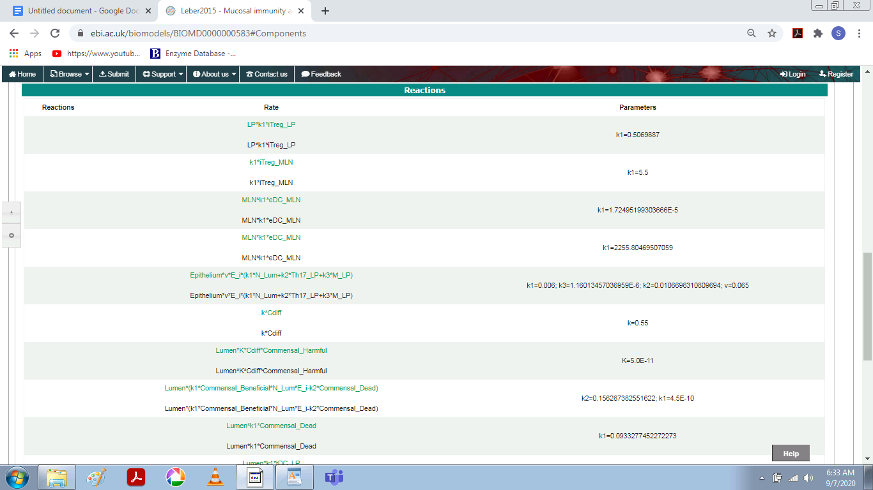

**D). FOR YEAST**

Model Name- Voit2003-Trehalose Cycle

Model Identifier- BIOMD0000000266

Given By- Kieran Smallbone, Rahuman Sheriff on 21-Jul-2010

Short Description- The physiological hallmark of heat-shock response in yeast is a rapid, enormous increase in the concentration of trehalose. Normally found in growing yeast cells and other organisms only as traces, trehalose becomes a crucial protector of proteins and membranes against a variety of stresses, including heat, cold, starvation, desiccation, osmotic or oxidative stress, and exposure to toxicants. Trehalose is produced from glucose 6-phosphate and uridine diphosphate glucose in a two-step process, and recycled to glucose by trehalose. Even though the trehalose cycle consists of only a few metabolites and enzymatic steps, its regulatory structure and operation are surprisingly complex.

Taxon- Saccharomyces cerevisiae (strain ATCC 204508 / S288c)

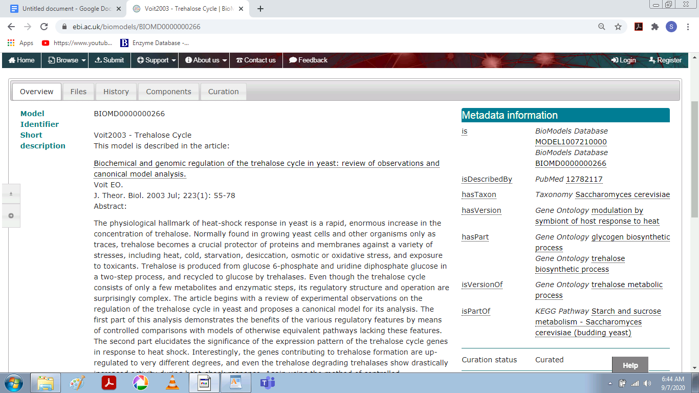

Format- SBML(L2V4)

Curation status- Manually curated

Number of species- 7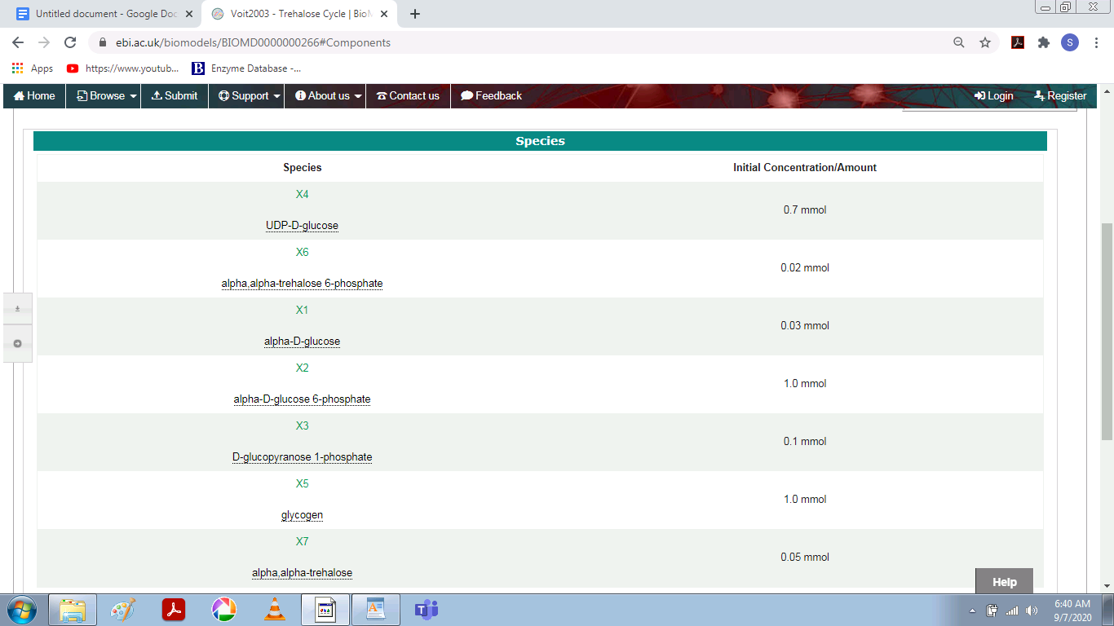

Number of reactions- 7

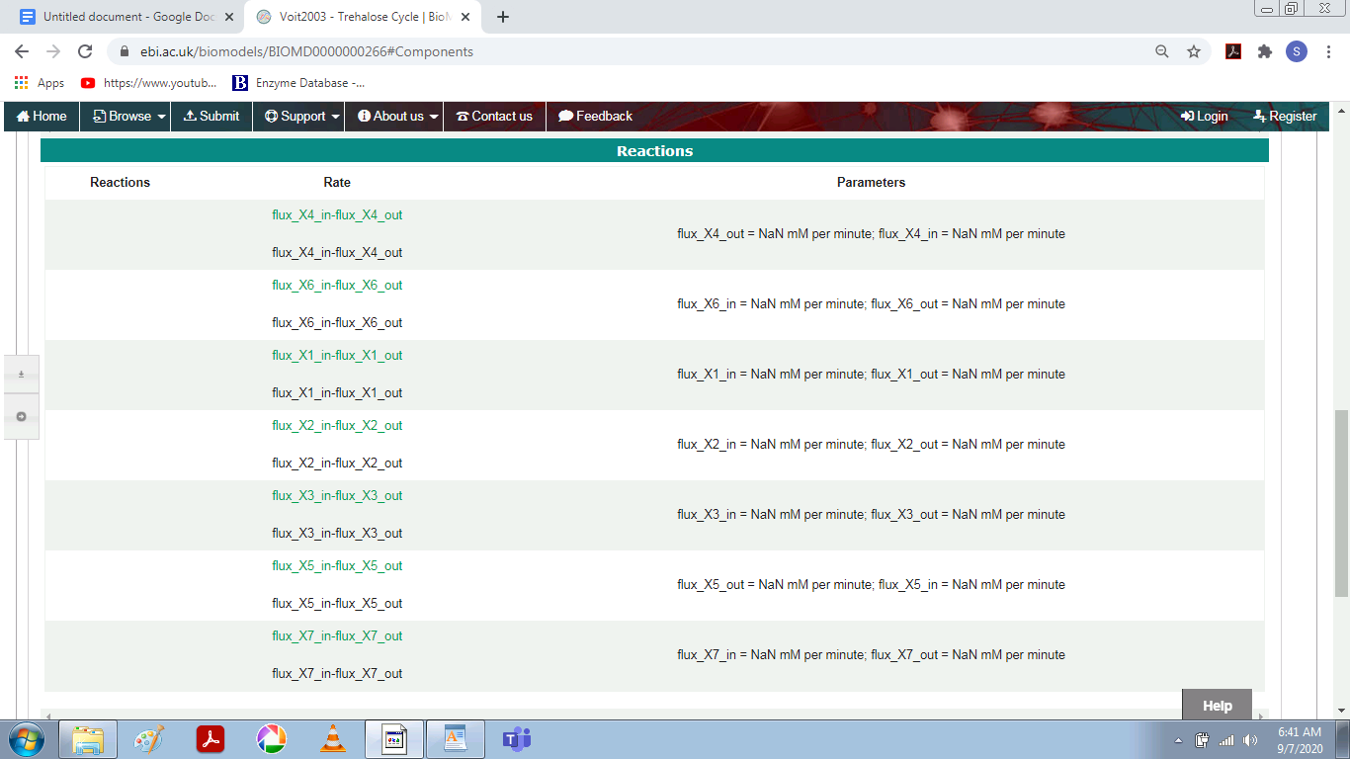

**E). FOR CANCER**

Model Name- Orton2009 - Modelling cancerous mutations in the EGFR/ERK pathway - EGF Model

Short Description-This model studies the aberrations in ERK signalling for different cancer mutations. The authors alter a previously existing EGF model (Brown et al 2004) to include new interactions that better fit empirical data. Predictions show that the ERK signalling is a robust mechanism taking different courses for different cancer mutations. Most parameter values are used from the previous model and the new parameters are estimated using experimental data performed by the authors on PC12 cells (adrenal gland, rat). The authors provide an SBML version of the model in the paper.

Model Identifier- BIOMD0000000623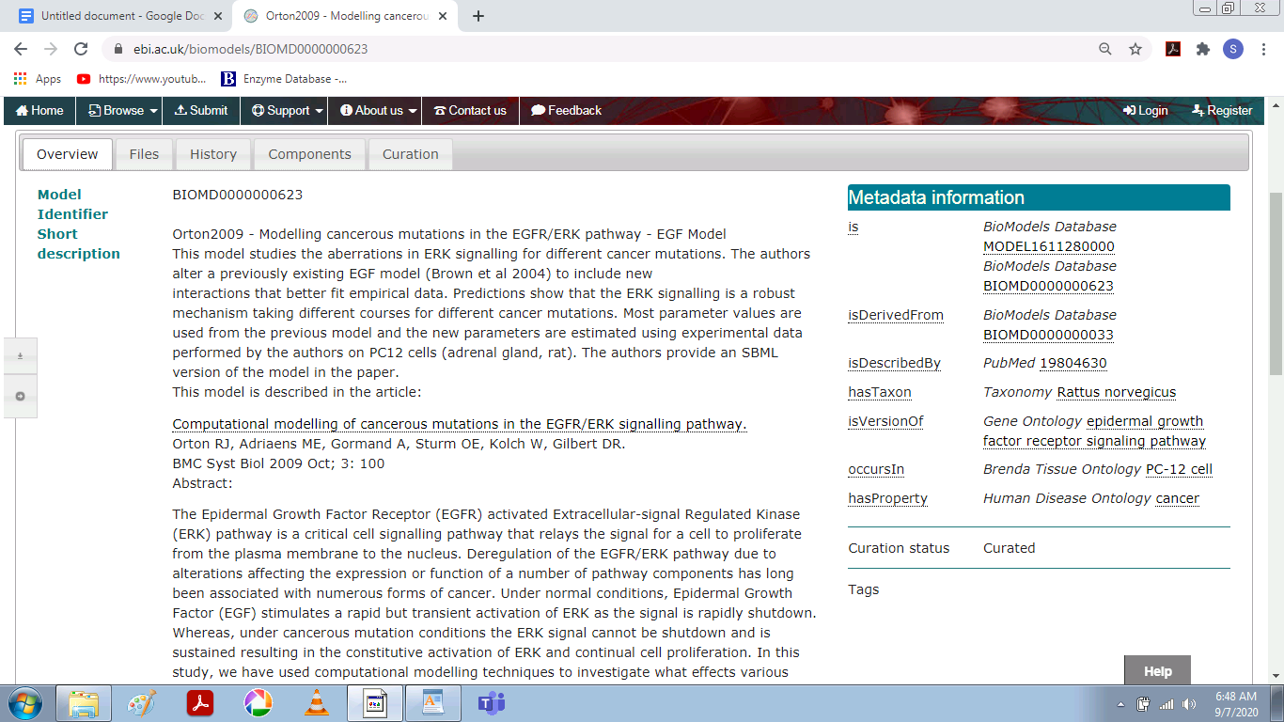

Given By- Thawfeek Varusai on 28-Nov-2016

Taxon- Rattus norvegicus

Format- SBML(L2V4)

Curation status- Manually curated

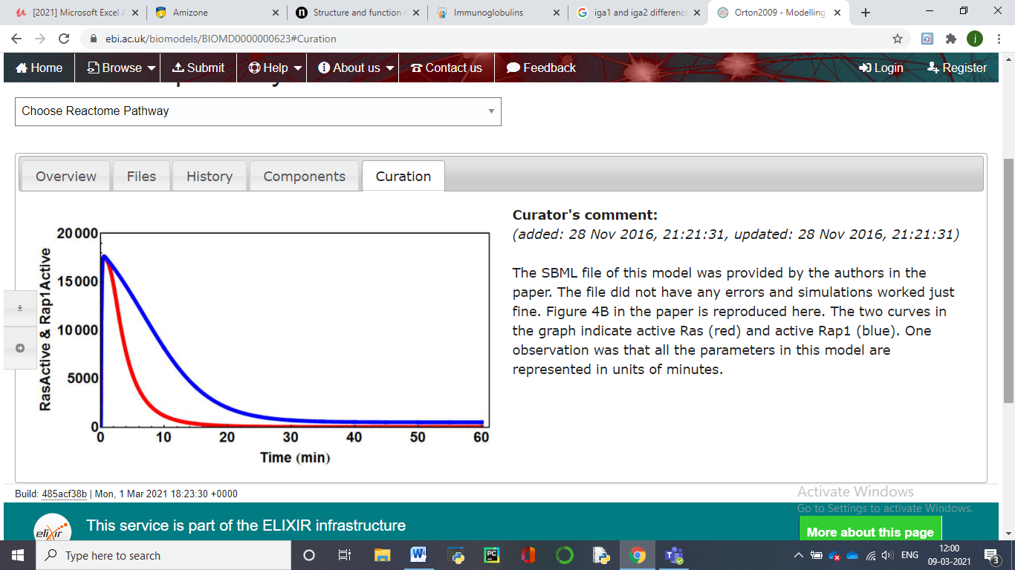

Number of species- 12

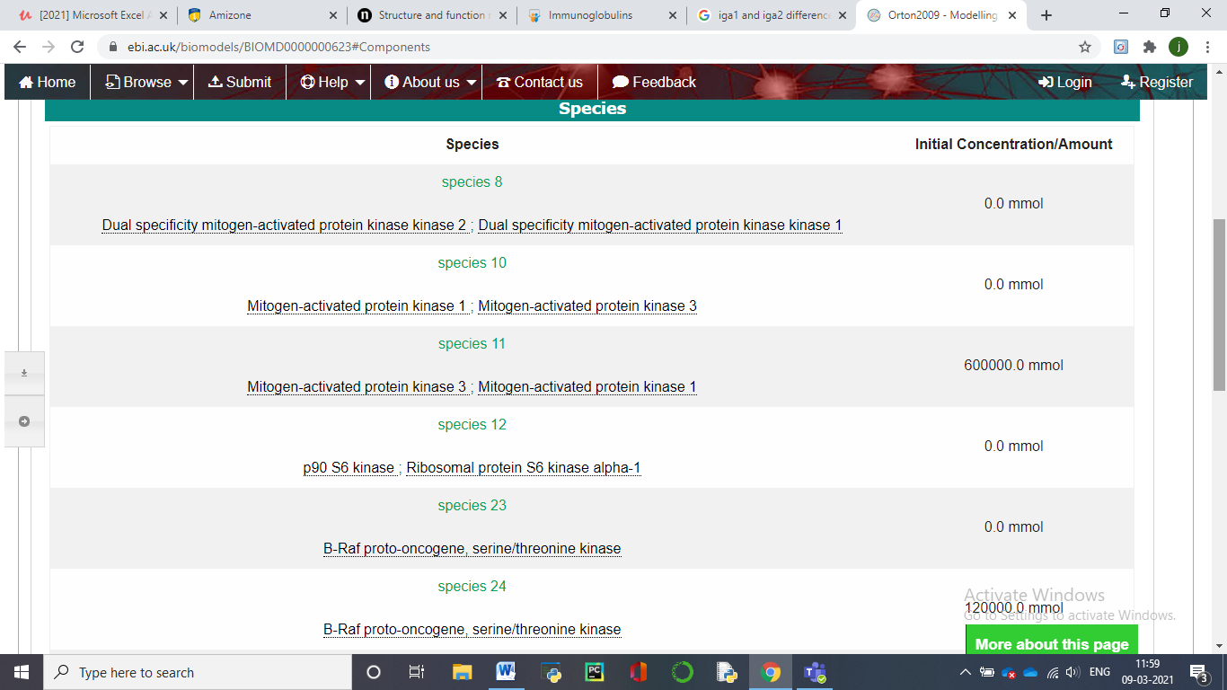

Number of reactions- 13

**EXPERIMENT-2**

**Aim**-

To explore Reactome database through the following questions.

**Theory**-

REACTOME is an open-source, open access, manually curated and peer-reviewed pathway database. Our goal is to provide intuitive bioinformatics tools for the visualization, interpretation and analysis of pathway knowledge to support basic and clinical research, genome analysis, modeling, systems biology and education. Founded in 2003, the Reactome project is led by Lincoln Stein of OICR, Peter D’Eustachio of NYULMC, Henning Hermjakob of EMBL-EBI, and Guanming Wu of OHSU.

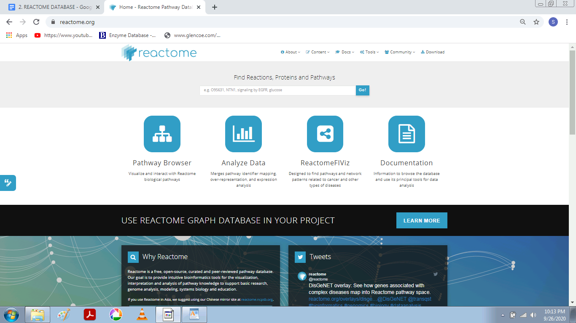

**How many human proteins are represented in Reactome?**

11,285

**What’s the first item listed that will be included in the next release?**

Autophagy [Homo sapiens] (DOI)

- Macroautophagy (DOI)

- Chaperone Mediated Autophagy (DOI)

- Late endosomal microautophagy (DOI)

4. **Is VAV2 in Reactome?**

Yes

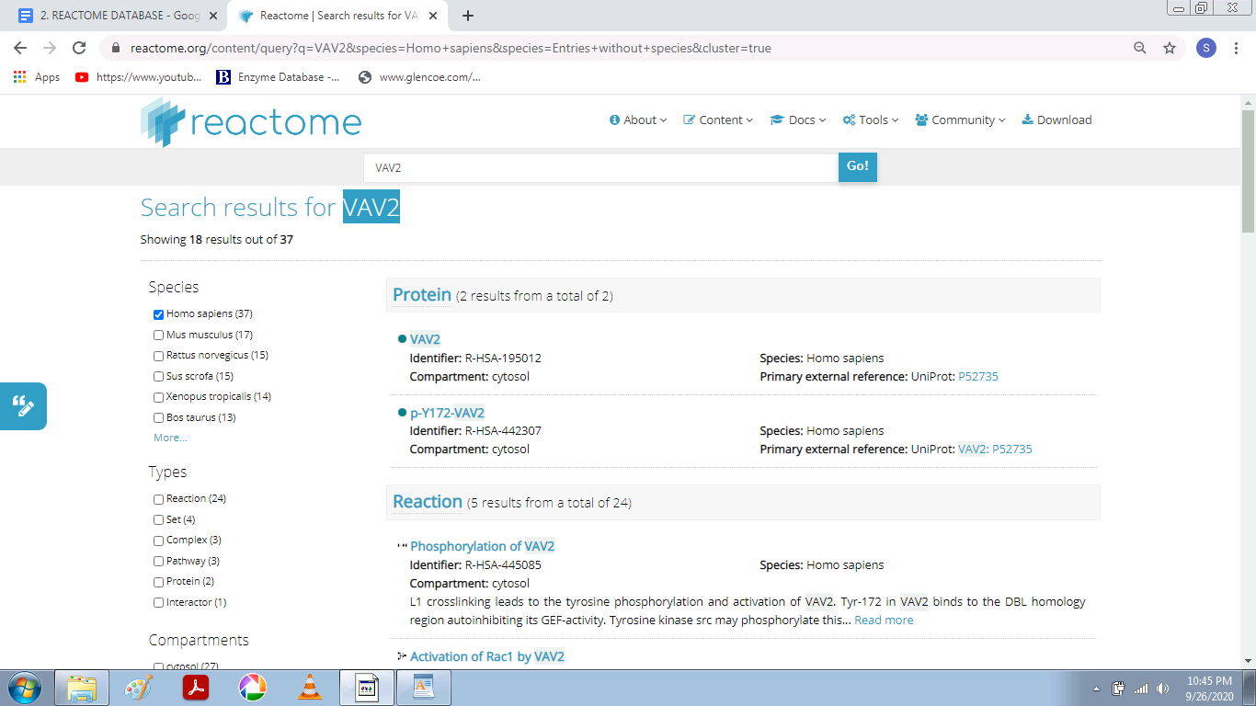

**How many reactions involve VAV2?**

36

**Are there any complexes that include VAV2?**

3

**Is CRB2 in Reactome?**

Yes

**Disease in Reactome**

Reactome can annotate and display pathways associated with disease. Disease events or processes are overlaid onto their normal counterparts to provide a pathway context to the disease event. Disease events have red connecting lines; abnormal molecules involved in these processes are outlined in red. For cancer-related processes, it is useful to view the altered disease events alongside their normal counterparts in the same diagram. The user can then see where normal processes diverge into ones that are implicated in cancer.

For infection processes, events involved in the life cycle of the infecting agent and host interactions with the infecting agent have red connecting lines. Molecules derived from the infecting agent are outlined in red, while those derived from the host are outlined as normal in black.

For metabolic processes, proteins that have lost all or most of their functional activity towards a substrate causes the majority of defects. The diagram displays these disease reactions as &#39;stop points&#39; in the pathway. Defective enzyme catalysts are outlined by a red dashed line; products that are no longer made are shown greyed- out with a superimposed red cross.

**Exercise**

1. **Search for the pathway FGFR1 mutant receptor activation and open it.**

Here we searched for FGFR1 mutant receptor activation pathway and the below displayed screen was displayed.

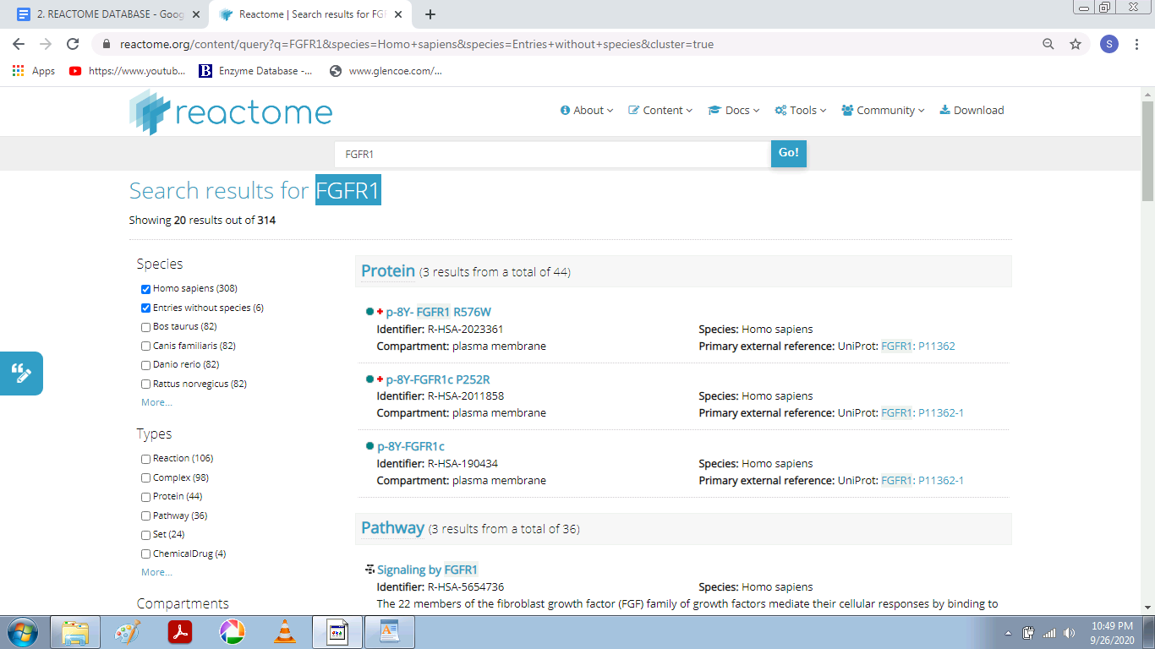

**The screen shows the protein molecule with the name FGFR1 and below that the pathways in which it is involved.**

**2. What disease(s) is/are associated with this pathway? (Hint: look at the Description tab, in the Details section)**.

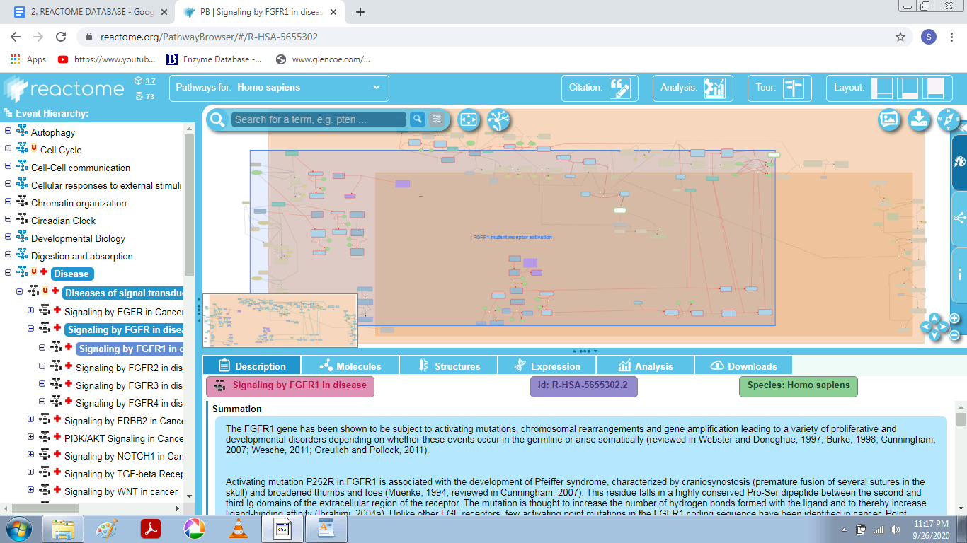

In the description tab, we can see that the **summation** of the FGFR1 gene is given,

Below that disease tab is given and it mentions **‘Bone development disease and Cancer’.**

**2. Search for the reaction Defective MMADHC does not bind MMACHC:B12r.**

What type of defect has caused this loss of function? (Hint: look at the

Functional Status category for the reaction).

Defects in MMADHC cause methylmalonic aciduria and homocystinuria type cblD (MMAHCD; MIM:277410), a disorder of cobalamin metabolism characterized by decreased levels of the coenzymes adenosylcobalamin (AdoCbl) and methylcobalamin (MeCbl) (Coelho et al. 2008). There are 3 biochemical phenotypes for this disorder; sufferers with homocystinuria (mutants L259P, T182N and Y249C), methylmalonic aciduria (mutants S20*, and R54*), and combined homocystinuria and methylmalonic aciduria (mutants R250* and Y140*)

How many mutations of MMADHC are represented?

MMADHC L259P [cytosol] (Homo sapiens)

MMADHC R250* [cytosol] (Homo sapiens)

MMADHC R54* [cytosol] (Homo sapiens)

MMADHC S20* [cytosol] (Homo sapiens)

MMADHC T182N [cytosol] (Homo sapiens)

MMADHC Y140* [cytosol] (Homo sapiens)

MMADHC Y249C [cytosol] (Homo sapiens)

**Here the below Screenshot shows the interaction with other molecules:**

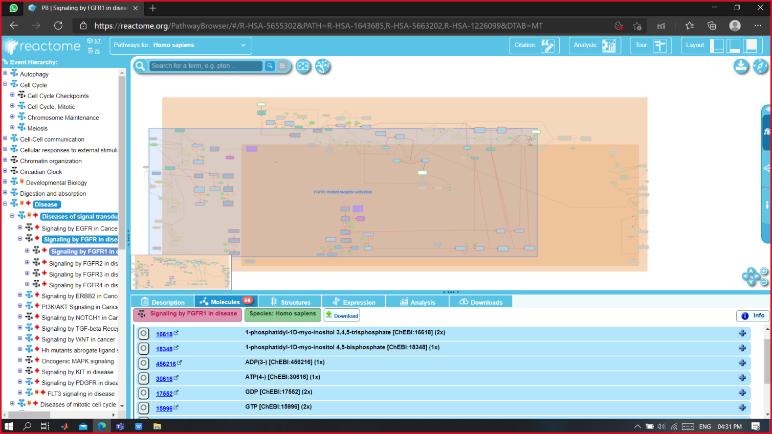

1. The molecules tab shows all the molecules of the complete pathway diagram.
2. Molecules are grouped in chemical compounds, Proteins, Sequences and other.
3. The molecules of a selected object appear highlighted in the diagram (as shown in the picture).
4. For each molecules we can see a symbol and a link to the main reference Database, a name and the number of occurrences in the pathway.
5. Clicking on the symbol several times will allow to circle through all **its occurrences** in the diagram.
6. Expanding by clicking on the **‘+’** will provide with further external links.
7. Lists can be downloaded. Just click on the button in the top right corner, select the fields and types with interest and click **‘Start Download’**.

**In the expression tab we can view the expression level of the disease related molecules :**

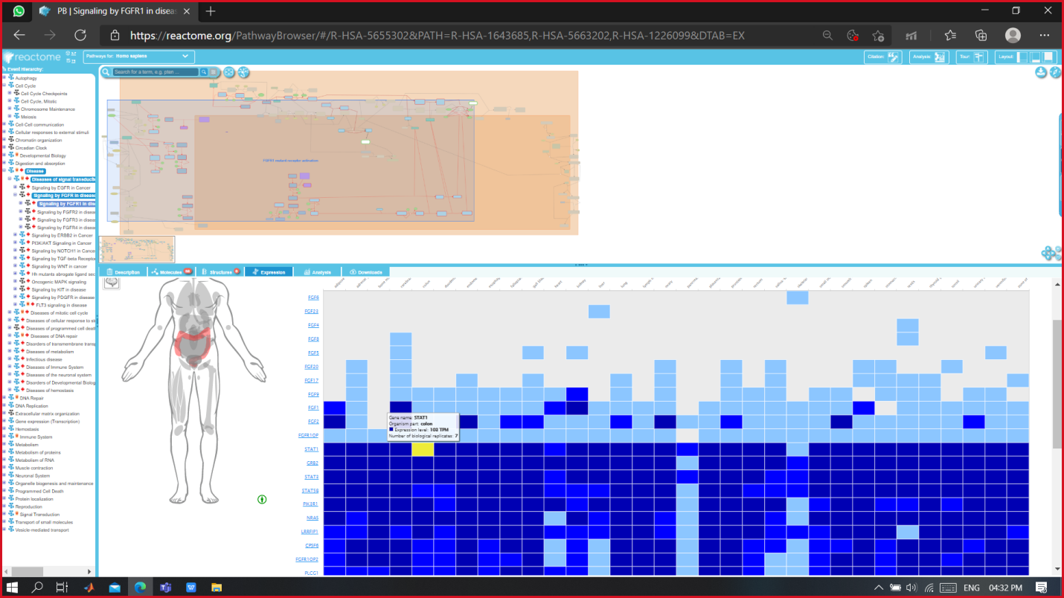

The expression tab gives the amount of molecule expressed in various parts of the body.

**How to look for the expressions?**

When we hover the mouse cursor over the expression blocks we can see the organ highlighted on which that expression is concerned.

**The darker blue color blocks show greater expression rates as compared to light blue zones.**

**When we click on any molecule from the tab to see its expression, the below window opens. The selected molecule is the highlighted in the network.**

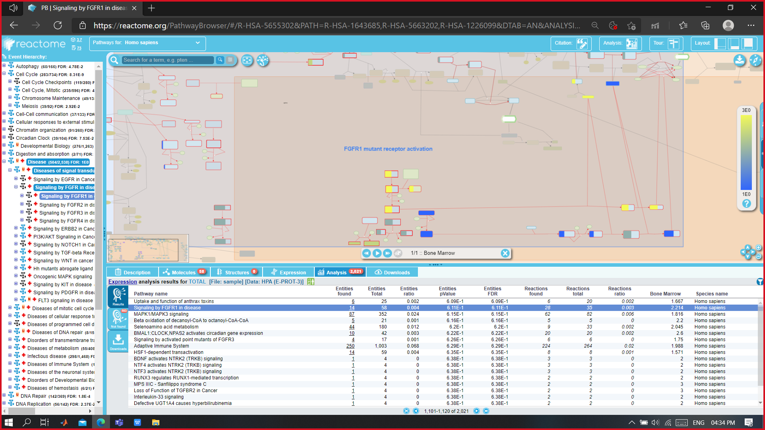

**Further zooming-in : We can visualize the network molecules with their interactions.**

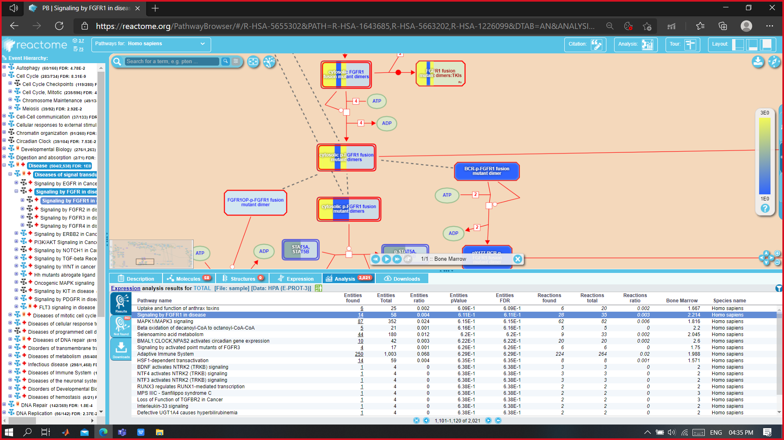

Here we can see the signaling of FGFR1 in disease.

From the download tab, we can download the structural data of any molecule of interest:

We can choose from various formats available for downloads for **Pathway Format** and for **Pathway Diagram**

**Pathway Formats:**

* SBML
* SBGN
* BIOPAX 2
* BIOPAX 3
* PDF

**Pathway Diagram formats:**

* SVG
* PNG
* JPEG
* GIF

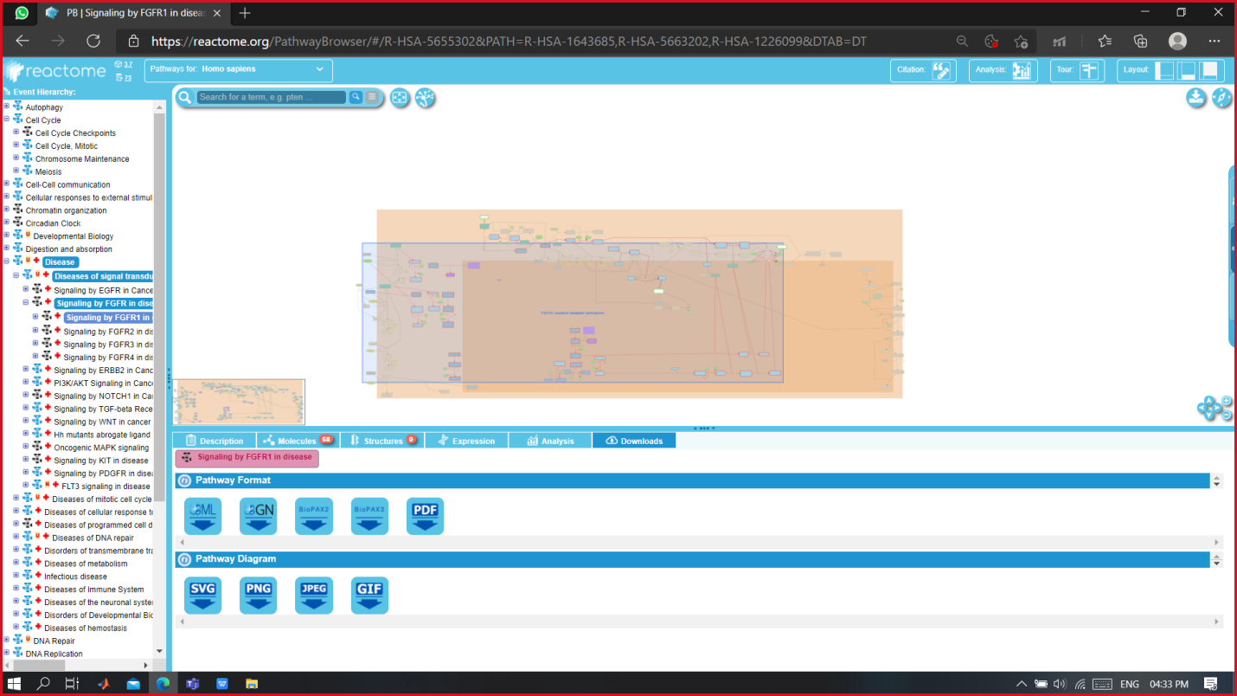

**Species Comparison Analysis**

If we wish to compare the molecule or pathway of interest of one organism to another we can do that too:

Click on the analysis button on the top right bar.a window will pop up: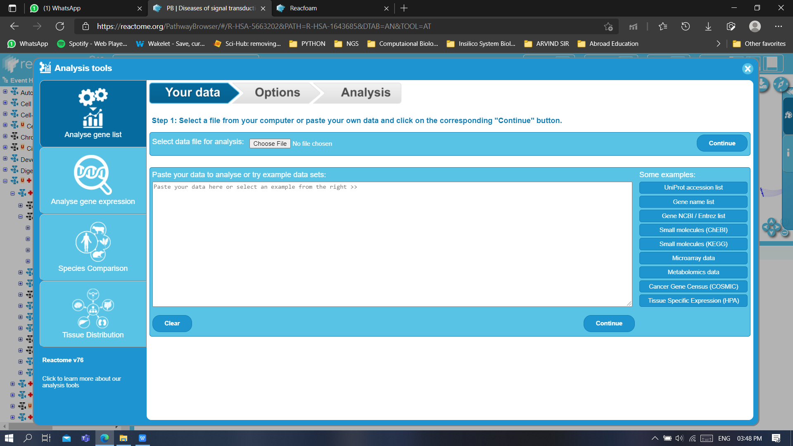

1. Here we get different options for our analysis. Lets go to Species comparison:

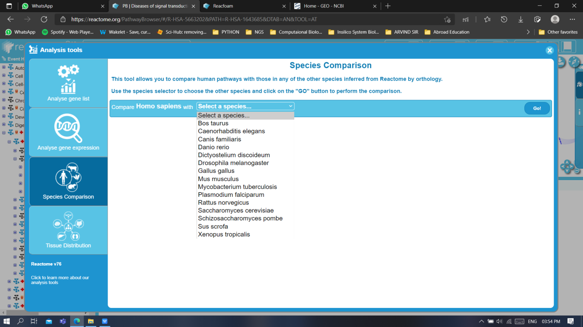

1. From the drop-down menu let’s choose *Mus musculus* and hit **GO!**.
2. We can now see the comparison of *Homo sapiens* with *Mus musculus.*

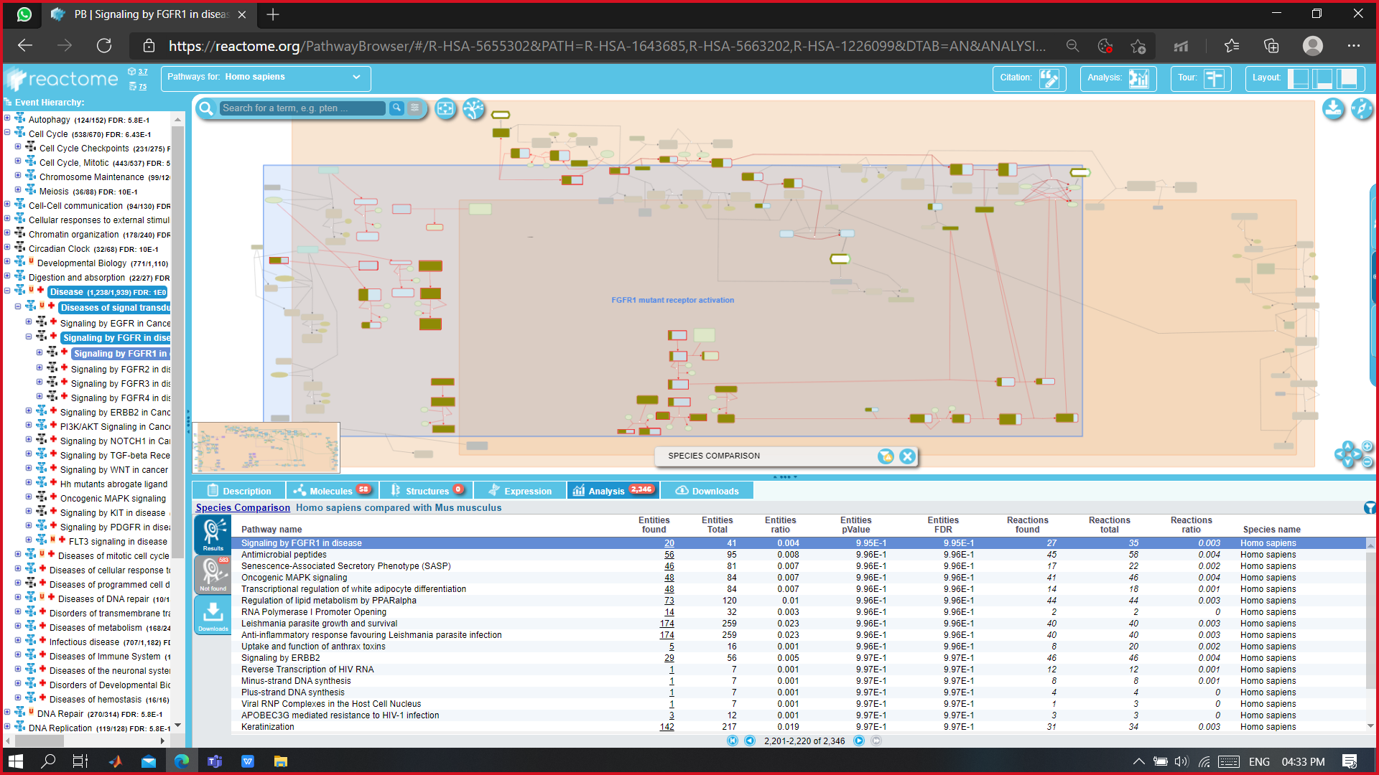

**There are various other species as well with which these comparative analysis can be seen.**

**EXPERIMENT -3**

**Aim-** To explore KEGG database through the following exercise.

**Theory-** KEGG is a database resource for understanding high-level functions and utilities of the biological system, such as the cell, the organism and the ecosystem, from molecular-level information, especially large-scale molecular datasets generated by genome sequencing and other high-throughput experimental technologies.

**How to find a standard metabolic pathway in KEGG ?** 

* From the KEGG [table of contents](http://www.genome.ad.jp/kegg/kegg2.html) click on the link '[Metabolic pathways](http://www.genome.ad.jp/kegg/metabolism.html)' under pathway category.
* A list with all pathways will be available.
* To find the pathway link for **'Lysine biosynthesis'**, scroll down on the browser to the group of pathways called 'amino acid metabolism' and click on the link.

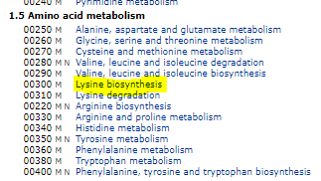

**Fig 1.0**

**Scroll down to the portion where heading 1.5 is given or press ctrl+f and then type in LYSINE BIOSYNTHESIS**

**Visualizing the standard map after clicking on the link**

You should now see the standard pathway [MAP00300](http://www.genome.ad.jp/kegg/pathway/map/map00300.html) for lysine biosynthesis.

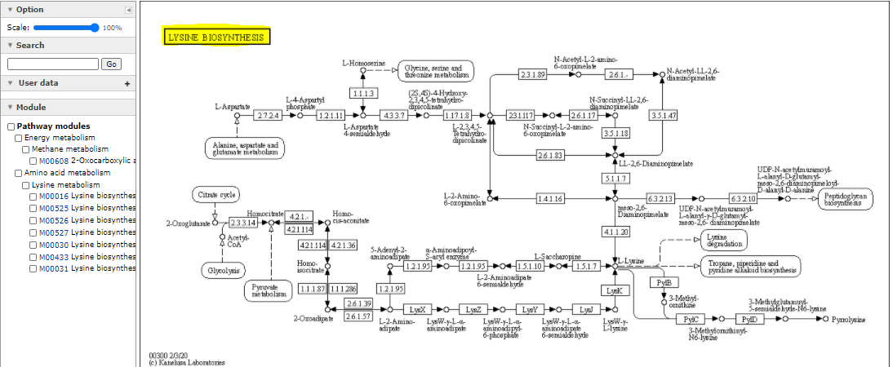

**Fig 2.0**

**1.How to find a species specific pathway map?**

**Go to change pathway type search the organism or the species you want to select (ctrl+f ) and then click the link left hand side of it .**

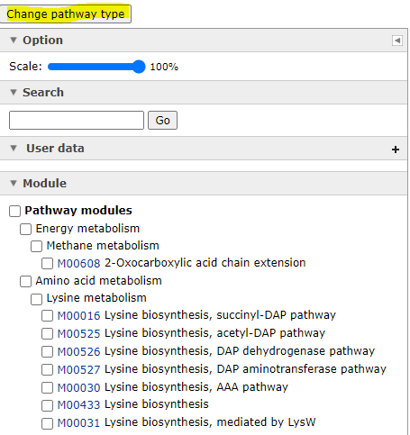 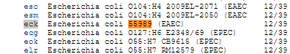

**Fig 3.0 Fig 4.0**

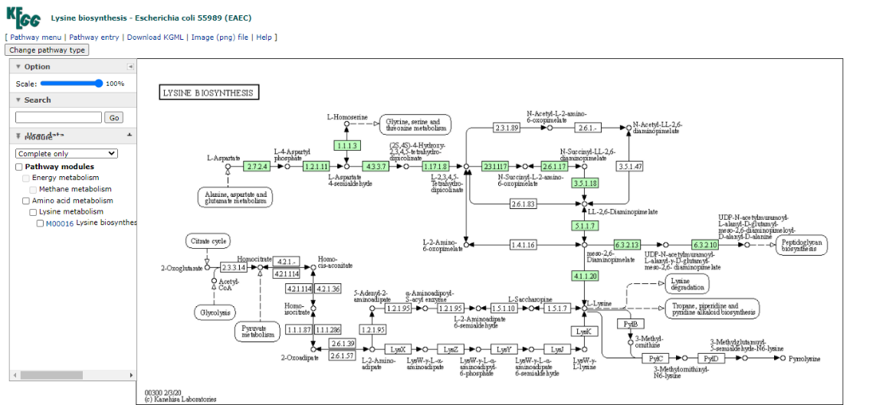

**Fig 5.0**

* All known E.coli enzymes for which a database entry exists are labelled in green. Not all enzymes are coloured which indicates that the corresponding enzyme (pathway) does not exist in this organism or that no information is found in any of the public databases (Swiss Prot, GenBank, Protein Data Base etc.).
* Since the [complete genome](http://www.genome.ad.jp/dbget-bin/get_htext?E.coli.kegg+B) for E.coli has been sequenced this very likely indicates that complete information is available about this Gram-negative bacteria. However, about 39% of all predicted genes (called ORFs or open reading frames) are not associated with any known protein, biochemical or physiological activity and therefore not all pathways are known and not described in KEGG.
* Some organisms such as mouse and human are not listed for lysine biosynthesis but show a map for [glutamate](http://www.genome.ad.jp/dbget-bin/get_pathway?org_name=hsa&mapno=00251), for example. **L-lysine, unlike glutamate, is an essential amino acid for both human and mouse. L-lysine has to be part of our diet, because we lack the necessary enzymes for its biosynthesis!!!**

1. **How to find a chemical structure and metabolite information from a pathway map?**

* Note that the immediate precursor of L-lysine also serves as a substrate for peptidoglycan synthesis to form the activated polypeptide **UDP-N-acetylmuramoyl-L-alanyl-D-glutamyl-meso-2,6-diaminopimelotl-D-alanyl-D-alanine** the structure of which can be found by clicking on the small circle next to the compound name.

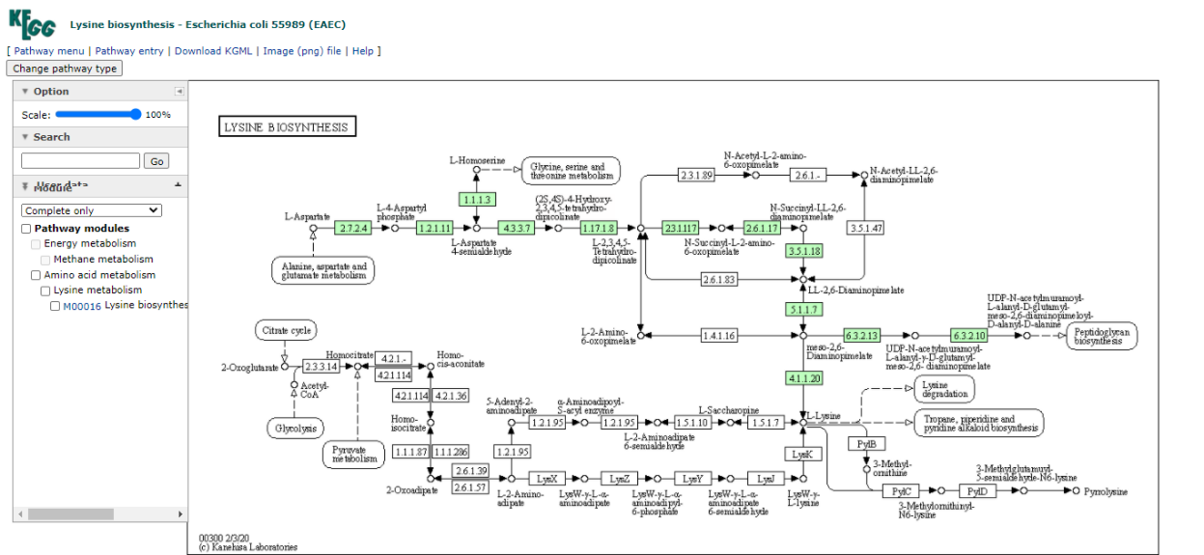

**Fig 6.0**

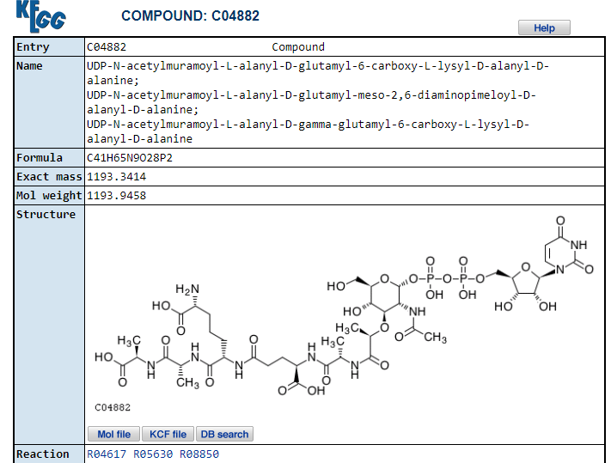

**Fig 7.0**

* You will see an information page for KEGG entry [C04882](http://www.genome.ad.jp/dbget-bin/www_bget?cpd:C04882).
* The preceding problem gives an example of how to find information about a metabolite, namely its chemical structure, formula, KEGG entry number, and pathway map numbers for which it is an intermediate.
* Clicking on a substrate name (or its circle) on a pathway map page is the easiest way to find relevant chemical information about a substrate and its shared pathways.
* The same can be done for an enzyme by clicking on the E.C. number box or for an intersecting pathway indicated in a roundish shaped box.
* For example, a link exists from the lysine biosynthesis map to the 'lysine degradation' pathway map. Clicking on the box marked '[Lysine degradation](http://www.genome.ad.jp/kegg/pathway/map/map00310.html)' will bring us to the corresponding catabolic processes. Note that the species selection will not change (we last selected *E.coli* pathways above).

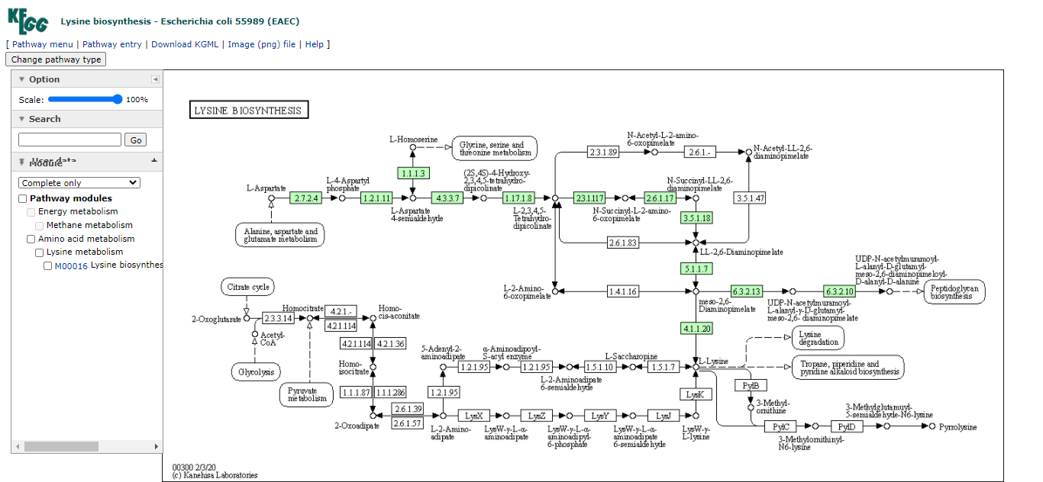

**Fig 8.0**

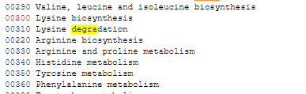

**Fig 9.0**

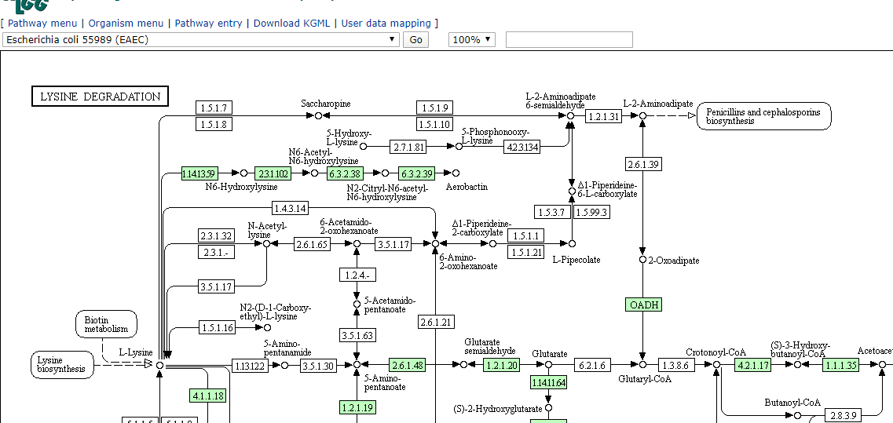

**Fig 10.0**

**1: How do I find a chemical structure, metabolite information by keyword search**?

* To find a pathway metabolite or enzyme, the table of contents offers a direct link to the DBGET Ligand database at KEGG.
* This search mode can be found at the 'table of contents' page under the 'enzyme' category, DBGET search.
* Click on the link called '[Ligand](http://www.genome.ad.jp/dbget-bin/www_bfind?ligand)' to access a generic search mode that allows a keyword entry.

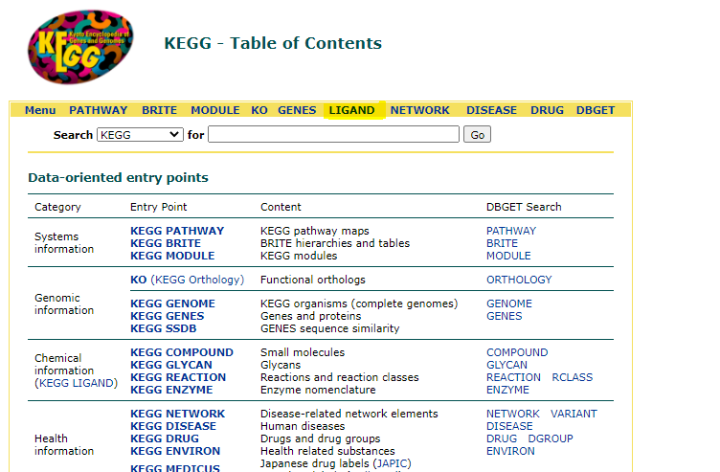

**Fig 11.0**

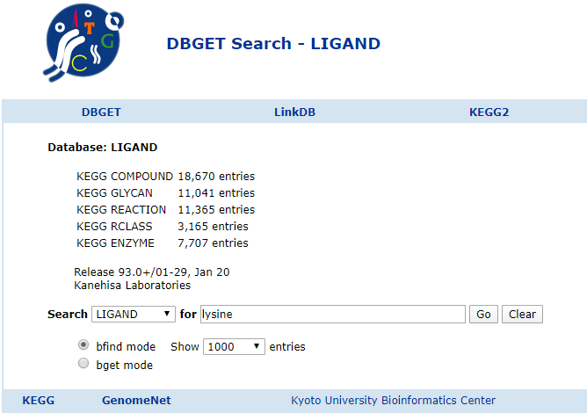

**Fig 12.0**

* Note that an exact enzyme number or compound number is not necessary in the DBGET database.
* To find information about lysine or L-lysine, type in 'lysine' and hit the return (enter) key. You will receive a return list with [159 hits](http://www.genome.ad.jp/dbget-bin/www_bfind_sub?dbkey=ligand&keywords=lysine&mode=bfind&max_hit=1000). The search returned all KEGG entries that contained the word 'lysine' anywhere in the enzyme or compound name.
* The list contains 45 enzyme links (ec: x.x.x.xx) and 51 compound links (cpd: Cxxxxx), one being L-lysine ([cpd:C00047](http://www.genome.ad.jp/dbget-bin/www_bget?cpd:C00047)) and all others derivatives thereof.

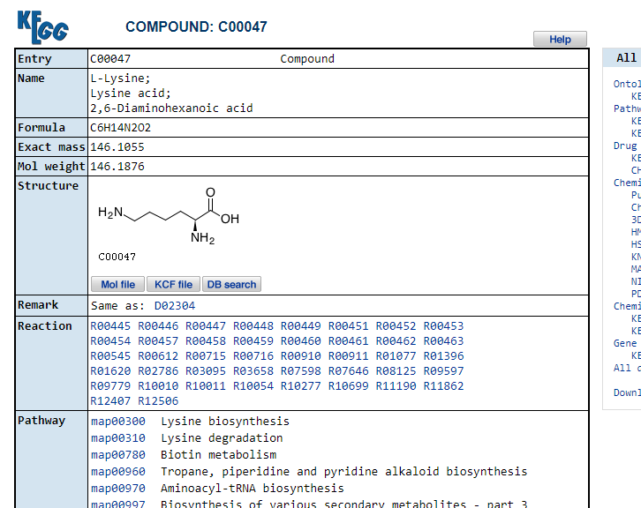

**Fig 13.0**

* Clicking on the cpd number will bring you to the chemical structure information sheet. This sheet lists compound entry number for L-lysine (note that D-lysine has a different entry, of course), common name(s), formula, structure, all pathway maps that contain L-lysine as metabolite (5 maps for L-lysine including synthesis and degradation, biotin metabolism, alkaloid biosynthesis II, and Aminoacyl-tRNA biosynthesis), and finally a list of all known enzymes that use L-lysine as a substrate.

**General information on biological molecules**

* One additional feature that is very helpful to use are the molecular catalogue entries, specifically the '[compound classification](http://www.genome.ad.jp/kegg/catalog/compounds.html)'.
* This link leads to a catalogue of metabolites classified according to their functional class, e.g., carbohydrates, fatty acids, phospholipids, neurotransmitters etc..

If you want to look up the structures of a class of molecules like the amino acids or various hexoses, this link will give you the best and broadest result to quickly find what you need.

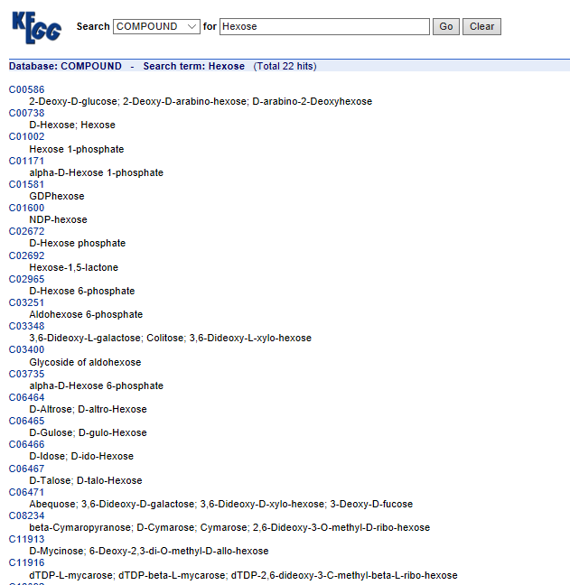

**Fig 14.0**

**Can be accessed from Table Of Contents**

* Use this link as a reference for structure information. As an example we are interested in the general structure of [steroid hormones](http://www.genome.ad.jp/kegg/catalog/cpd_steroid_hormone.html).
* A link provided in the category 'Lipids' provides a page containing the names and chemical structures of seven cholesterol derived steroid hormones.

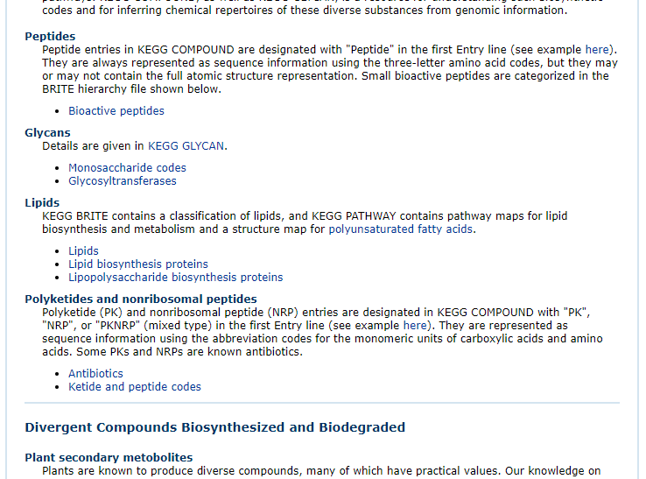

**Fig 15.0**

* Clicking on the name link '[aldosterone](http://www.genome.ad.jp/dbget-bin/www_bget?cpd:C01780)' connects to a structure information page providing a link to the pathway map for C21 steroid hormone metabolism ([MAP00140](http://www.genome.ad.jp/dbget-bin/show_pathway?MAP00140+C01780)).

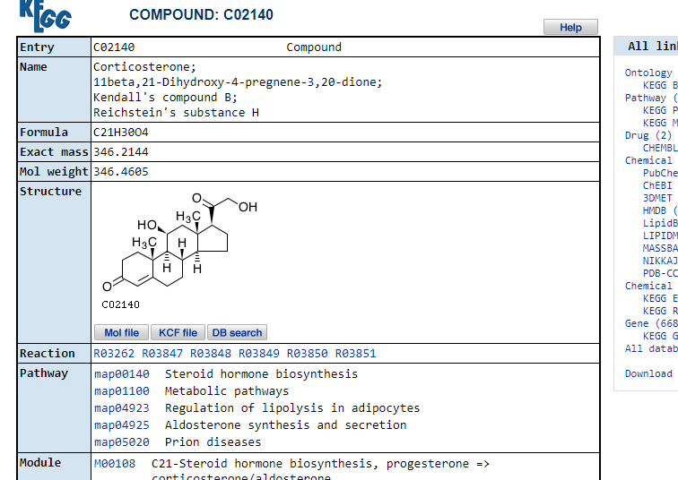

**Fig 16.0**

* Following the pathway map link results in the standard pathway for steroid hormone metabolism with aldosterone position marked as a red circle (because we started our search from aldosterone).

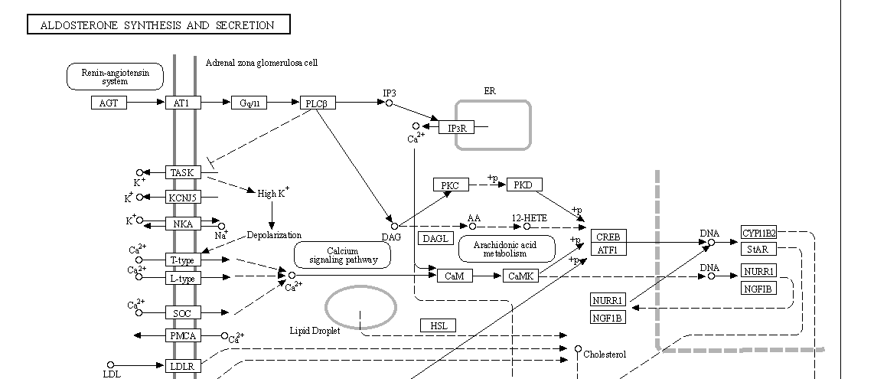

**Fig 17.0**

* Selecting the [Homo sapiens](http://www.genome.ad.jp/dbget-bin/get_pathway?org_name=hsa&mapno=00140) version of the map shows as a variety of pathways whereas no corresponding [bacterial map for E.coli](http://www.genome.ad.jp/dbget-bin/get_pathway?org_name=eco&mapno=00140) exists. Not surprisingly, because microorganisms lack the capability of synthesizing steroid hormones. The database offers only links to eukaryotic organisms.

**Why are some enzymes not colored even though they are part of a pathway of enzymes that are colored?**

* Sometimes an enzyme is not marked where you would expect it like in the aldosterone pathway above.
* This pathway map shows all known reactions summarized in a standard pathway map. Species specific enzymes are marked green.
* Missing enzymes that appear to interrupt a pathway occur when no entry for this enzyme (gene, amino acid sequence, protein structure) exists in *any* database, not only KEGG.
* The enzyme with the entry [EC 1.14.15.5](http://www.genome.ad.jp/dbget-bin/www_bget?enzyme+1.14.15.5) is *Corticosterone 18-monooxygenase* and converts corticosterone into aldosterone.

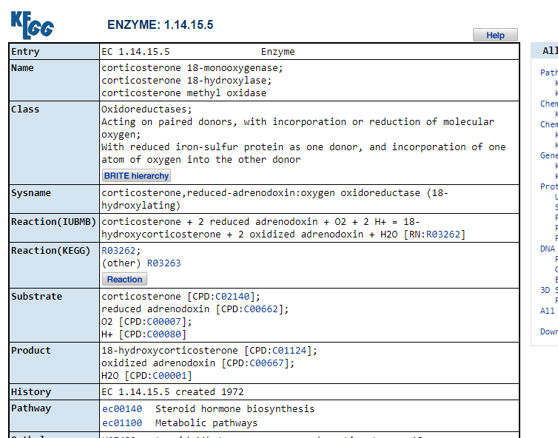

**Fig 18.0**

* Following the E.C. link for this enzyme to the entry in [GenBank](http://www.genome.ad.jp/dbget-bin/www_bget?genbank-today+D14097) (mirrored from NCBI) shows one nucleic acid sequence report for rat (exon 9 of Rat CYP11B2 gene for aldosterone synthase).

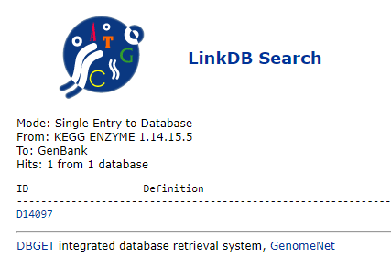

**Fig 19.0**

**EXPERIMENT- 4**

**AIM :** To explore and search Chlamydomonas glycolytic pathway using Biocyc database.

**THEORY:** Biocyc is a collection of pathway and genome databases for model organisms, and it has more software tools for analysis.

Biocyc database collection

The BioCyc collection of Pathway/Genome Databases (PGDBs) provides a reference on the genomes, metabolic pathways, and (in some cases) regulatory networks of thousands of sequenced organisms. Each database combines information from three sources:

* **Computational inferences:** Our Pathway Tools software predicts the metabolic pathways of an organism, predicts which genes code for missing enzymes in metabolic pathways, and predicts operons. We compute orthologs across BioCyc databases.
* **Imported data:** BioCyc integrates information from other bioinformatics databases, such as protein feature and Gene Ontology information from UniProt, gene-essentiality datasets from OGEE, and regulatory information from RegTransBase.
* **Manual curation:** The curated databases (called [Tier 1 and Tier 2 PGDBs](https://biocyc.org/biocyc-pgdb-list.shtml#tier1)) have received literature-based curation to enter new gene functions, pathways, protein complexes, regulation, and more.

The [EcoCyc](https://biocyc.org/ecocyc/index.shtml) DB is the result of more than 20 person-years of effort to enter information from 40,000+ *E. coli* articles about gene function, metabolism, transport, and regulatory processes.

The [MetaCyc](https://metacyc.org/) DB describes metabolic pathways, enzymes,and metabolites from all domains of life, curated from 65,000+ publications.

The EcoCyc and MetaCyc databases are freely available to all users because their curation is supported by NIH funding. The other BioCyc databases are available via subscription, which supports their curation. To obtain free access to the other BioCyc databases for teaching purposes, please [click here.](https://www.phoenixbioinformatics.org/biocyc)

BioCyc data files may be [downloaded](https://biocyc.org/download.shtml) to your site, and BioCyc data can be queried via [web services](https://biocyc.org/web-services.shtml).

**BioCyc.org Bioinformatics Tools**

[BioCyc.org](https://biocyc.org/) provides a suite of bioinformatics tools (see Tools menu) for accessing and analyzing the BioCyc databases. The tools provide search and visualization, omics data analysis, and comparative genomics and comparative pathway analysis:

* **Search:** Multiple [search](https://biocyc.org/PToolsWebsiteHowto.shtml#SearchHelp) tools enable users to find genes, pathways, and metabolites of interest, which are presented in corresponding information pages. Most searches apply to the currently selected organism database, which can be changed with the "Change Current Database" button at the top of most pages. There are two ways to search across multiple databases: (1) Use **Tools → Search → Cross Organism Search** or (2) In commands such as **Tools → Search → Search Genes, Proteins, and RNAs**, select "Search across multiple organisms/databases" under the list of buttons.
* **Visualization:** A variety of visualization tools are provided, such as metabolic-pathway diagrams, and zoomable diagrams depicting the complete metabolic chart of each organism [[example]](https://biocyc.org/ECOLI/new-image?type=OVERVIEW).
* **Genome Browser:** The BioCyc genome browser [[example]](https://biocyc.org/ECOLI/new-image?type=FULL-MAP&object=EG10235) enables analysis of positional genome datasets via tracks.
* **Omics Data Analysis:** Tools include statistical over-representation analysis; and visualization of gene expression, proteomics, or metabolomics data on metabolic-chart diagrams [[example]](https://biocyc.org/expr-examples/animation.html) and on the Omics Dashboard [[example]](https://biocyc.org/dashboard/dashboard-intro.shtml).
* **SmartTables:** Biologist-friendly analysis capabilities for groups of genes or metabolites that are stored in your BioCyc account.
* **Metabolic Route Search:** Search for reactions paths connecting specified metabolites in the metabolic network, with the option of adding new reactions from the MetaCyc DB.
* **Comparative Analysis:** Tools include comparison of pathways, metabolites, transporters, and regulatory networks -- (see menu command Analysis -> Comparative Analysis).
* **Sequence Analysis:** Perform BLAST searches, sequence pattern searches, and perform multiple alignments.

**Pathway Tools Software**

[Pathway Tools](http://pathwaytools.com/) is an enterprise genome and pathway data management tool and is among the most extensive bioinformatics software packages. It is the software used to create BioCyc databases and it powers the BioCyc.org website. Its capabilities are described in detail [here](http://arxiv.org/abs/1510.03964v4).

Pathway Tools can run as both a desktop application and as a web server.

Installing Pathway Tools at your site brings these advantages:

* Install a private local set of BioCyc PGDBs on your intranet
* Create new PGDBs from your own genome data, generating metabolic reconstructions, operon inferences, and more.
* Apply its extensive search, visualization, and analysis tools to your own genome data.
* Edit PGDBs interactively to add new gene functions and pathways
* Build quantitative metabolic flux models using Flux-Balance Analysis with the MetaFlux tool

**How to Learn More About BioCyc**

The following additional information exists about the BioCyc site:

* [Guided Tour:](https://biocyc.org/samples.shtml) Examples of data present in BioCyc
* [Webinars:](https://biocyc.org/webinars) Interactive online seminars describing how to use BioCyc
* [Website User's Guide:](https://biocyc.org/PToolsWebsiteHowto.shtml) Instructions for using the BioCyc Website
* [BioCyc User Guide:](https://biocyc.org/BioCycUserGuide.shtml) Information about the data content of BioCyc DBs
* [PGDB Concepts Guide:](https://biocyc.org/PGDBConceptsGuide.shtml) The ideas behind BioCyc
* [Publications:](https://biocyc.org/publications.shtml) Articles about BioCyc databases and the Pathway Tools software

**Definitions of Terminology on the BioCyc Website**

Here we define a few key terms. See the [glossary](https://biocyc.org/glossary.shtml) for more definitions.

**Pathway/Genome Database (PGDB).** A database that describes

* The genome of an organism -- its chromosome(s), genes, and genome sequence
* The product of each gene
* The metabolic network of the organism -- its pathways, reactions, enzymes, and metabolites
* The transporter complement of the organism
* The regulatory network of the organism, including its operons, transcription factors, and the interactions between transcription factors and their small-molecule ligands and DNA binding sites

**Tier 1 PGDB.** PGDBs in Tier 1, such as [EcoCyc](https://ecocyc.org/), [MetaCyc](https://metacyc.org/), and [HumanCyc](https://humancyc.org/), have received at least one year of literature-based curation by scientists. More information about curation practices is available in the [Curator Guide](https://bioinformatics.ai.sri.com/ptools/curatorsguide.pdf).

**Tier 2 PGDB.** PGDBs in Tier 2 were generated by the [PathoLogic](https://biocyc.org/intro.shtml#pathologic) program, which predicted their metabolic pathways; their operons (for bacteria only); and some missing enzymes in their predicted pathways (pathway hole fillers). The resulting PGDBs underwent manual review by a person to remove false-positive pathway predictions that they could detect, and to perform refinements such as defining protein complexes. The resulting PGDBs also underwent a period of literature-based curation, such as to enter metabolic pathways that had been experimentally elucidated in the organism but that were not inferred by [PathoLogic](https://biocyc.org/intro.shtml#pathologic). [[list of Tier 2 PGDBs]](https://biocyc.org/biocyc-pgdb-list.shtml#tier2)

**Tier 3 PGDB.** PGDBs in Tier 3 were generated by [PathoLogic](https://biocyc.org/intro.shtml#pathologic), which predicted metabolic pathways, operons (for bacteria only), pathway hole fillers, and transport reactions. The resulting PGDBs did not undergo manual review of the pathway predictions, nor subsequent literature curation. Therefore, the pathway predictions should be treated with due caution. [[list of Tier 3 PGDBs]](https://biocyc.org/biocyc-pgdb-list.shtml#tier3)

**Pathway Tools Software.** [Pathway Tools](http://bioinformatics.ai.sri.com/ptools/) is used to construct, update, visualize, query, and analyze PGDBs, such as the BioCyc collection. It is [freely available](https://biocyc.org/download.shtml) to academics interested in creating PGDBs for organisms of interest to them. Components of Pathway Tools are:

* The **Pathway/Genome Navigator** supports querying, visualization, and analysis of PGDBs
* The **Pathway/Genome Editors** support interactive updating and refinement of PGDBs
* [**PathoLogic**](https://biocyc.org/BioCycUserGuide#pathologic) performs computational inferences such as pathway prediction
* **MetaFlux** enables creation of quantitative metabolic models from PGDBs

**BioCyc:** The collection of PGDBs at URL [http://BioCyc.com/](https://biocyc.org/) is called the BioCyc Database Collection. EcoCyc and MetaCyc are component databases within the BioCyc collection.

**Procedure**

There is a search engine in which we can type our required query in the form of gene name, protein name, pathways name.

. 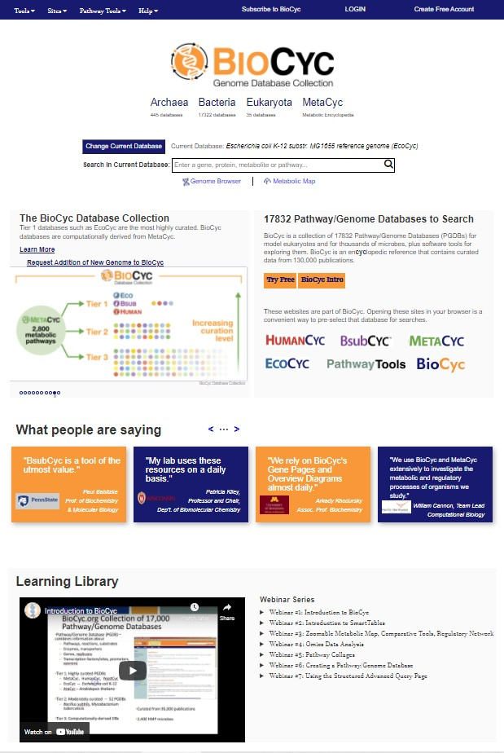

Biocyc database home page

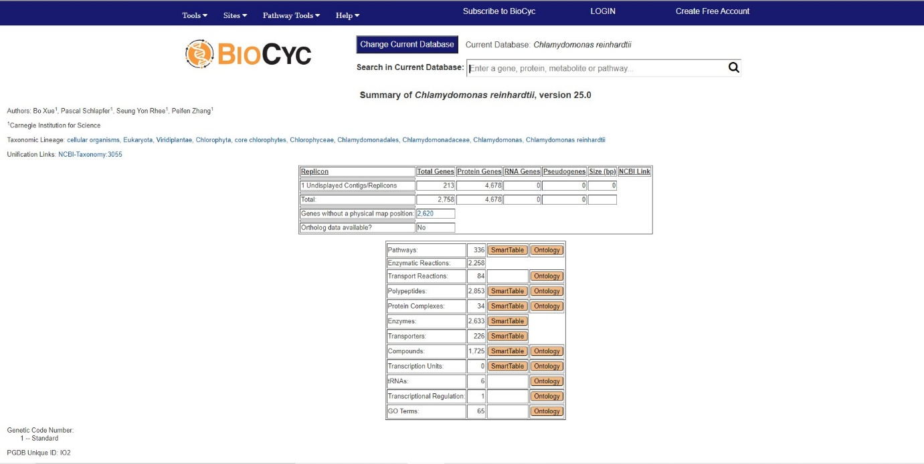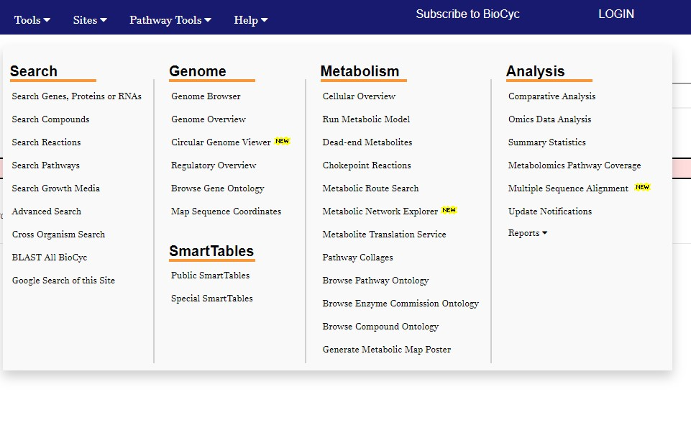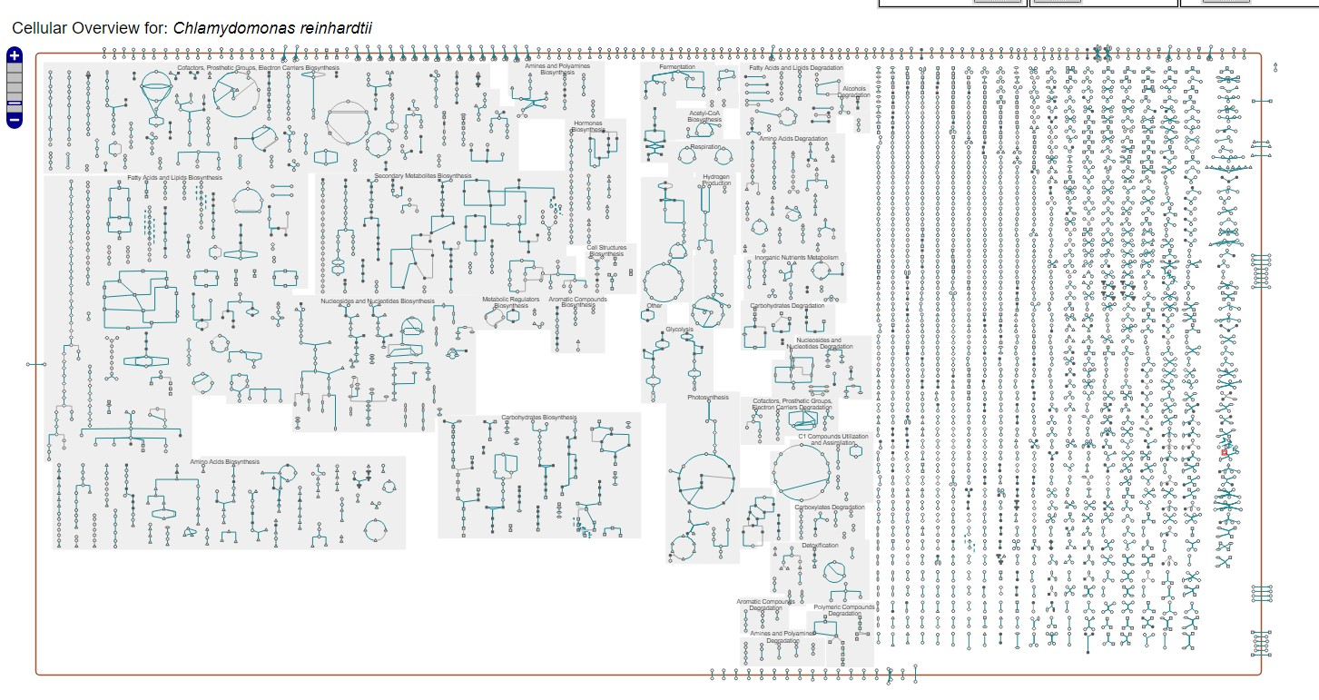

Searching tools

Cellular overview of Chlamydomonas

Glycolytic pathway of Chlamydomonas

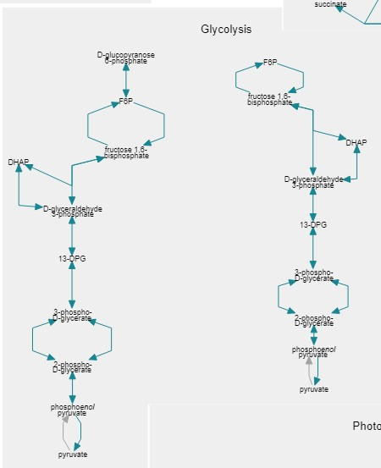

**Result** : Chlamydomonas glycolytic pathway is being traced and analysed.

**EXPERIMENT - 5**

**AIM: To upload and analyse yeast glycolytic model in JWS online**

URL : <https://jjj.biochem.sun.ac.za/>

**THEORY:**

JWS Online Database: Introduction

JWS Online is a web-based platform for construction, simulation and exchange of models in standard formats. We have extended the platform with a database for curated simulation experiments that can be accessed directly via a URL, allowing one-click reproduction of published results. Users can modify the simulation experiments and export them in standard formats. The Simulation database thus lowers the bar on exploring computational models, helps users create valid simulation descriptions and improves the reproducibility of published simulation experiments.

JWS Online has been optimised and tested on the following browsers:

● Google Chrome

● Chromium

● Safari

● Opera

Certain browsers are known to produce erroneous behaviour with JWS Online in ways that

are largely outside of our control:

● Firefox:

1) SVGs are not rendered correctly

1. mouse gestures are over-interpreted

Procedure:

Locating and Loading a model:

All models stored on JWS Online are assigned a unique slug for easy identification, and all models are stored under: http://jjj.bio.vu.nl/models/. For example, the yeast glycolytic model published by Teusink et al. (Can yeast glycolysis be understood in terms of in vitro kinetics of the constituent enzymes? Testing biochemistry.) is referred to on JWS online with the simple teusink slug, and thus can be accessed directly at:http://jjj.bio.vu.nl/models/teusink

1. Click on Model Database tab.

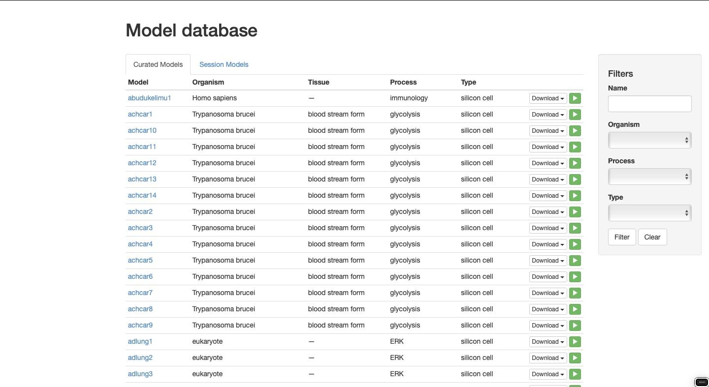

2.Type your complete query in search filter.

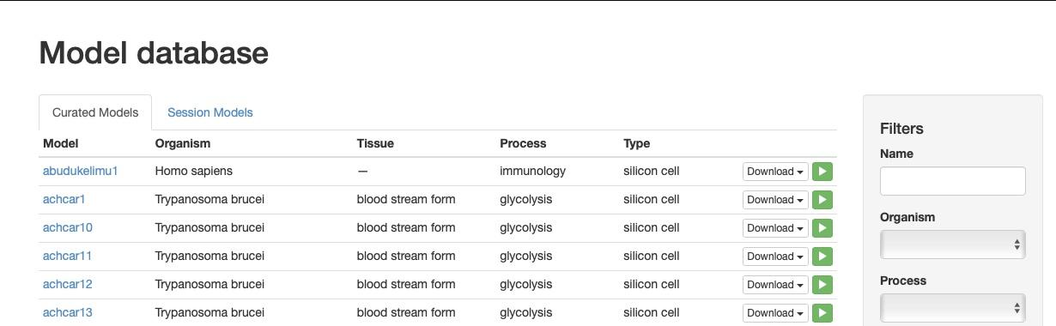

3.Each listed model has a set of action buttons. These buttons allow the model to be downloaded in SBML, Mathematica notebook, JWS, and PySCeS format respectively. The download button loads the model in the Model Simulation page. From this page all the simulation and analysis features of JWS Online can be explored.

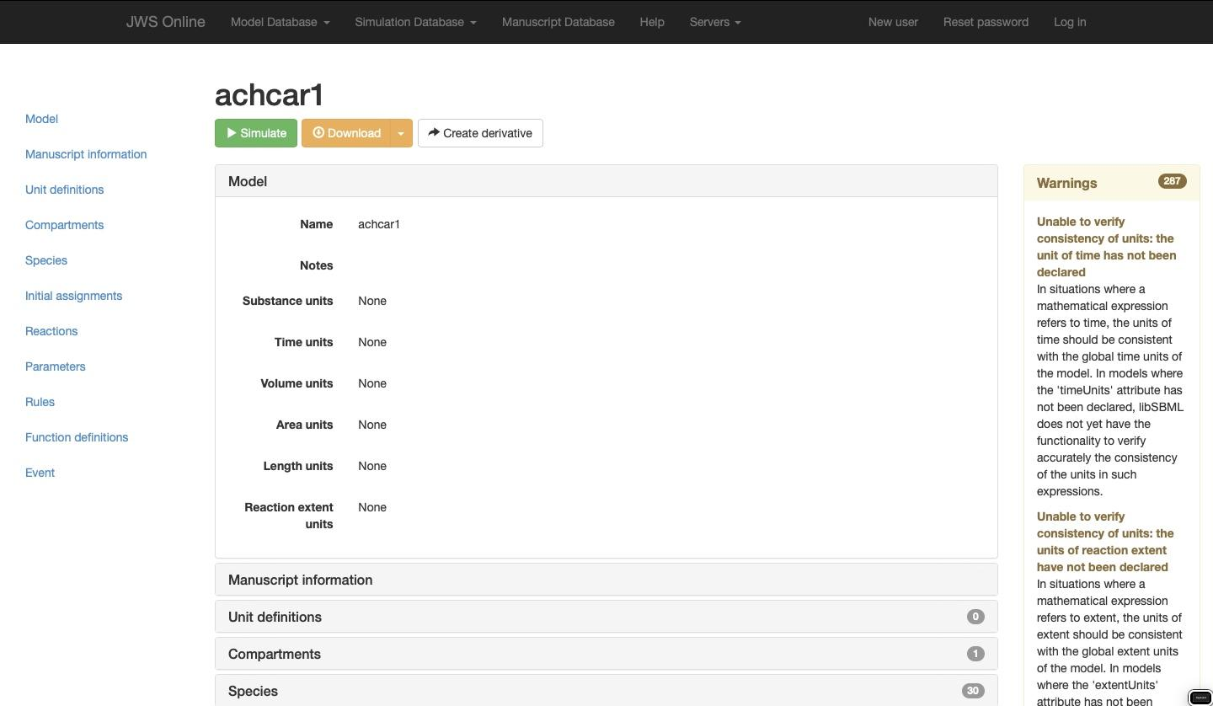

**SCHEMA:**

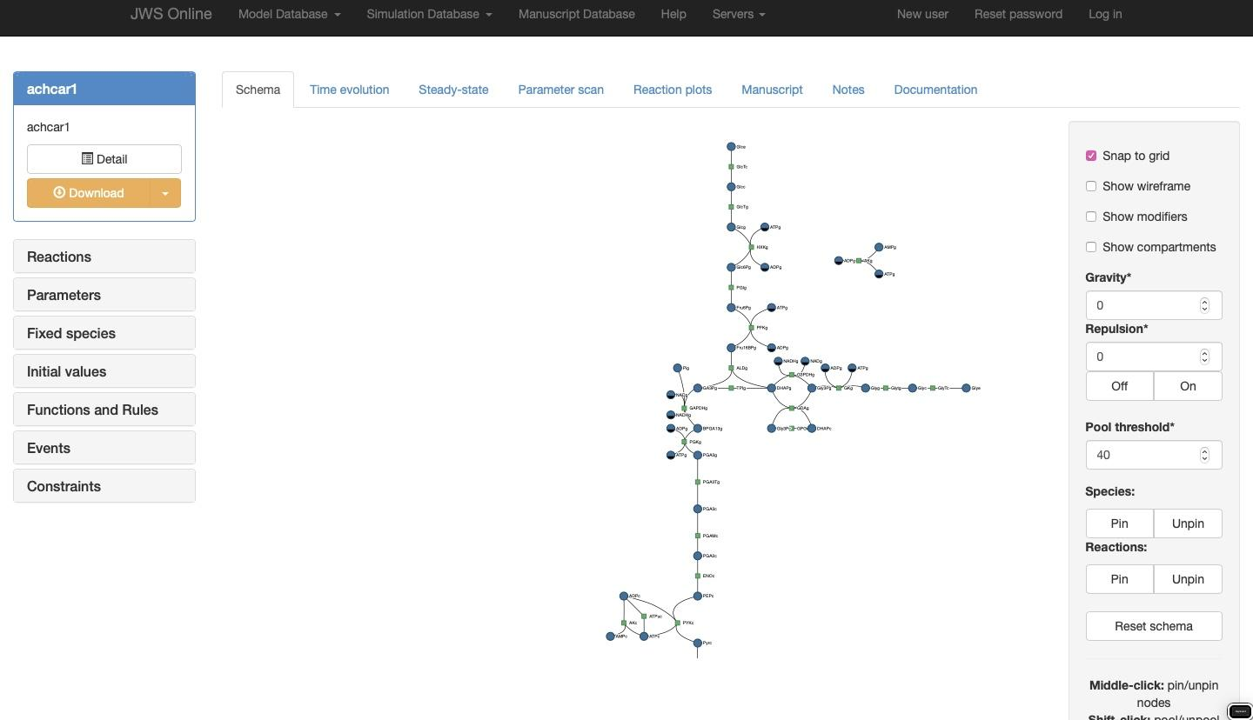

4.From this page all the simulation and analysis features of JWS Online can be explored.

The Schema: Models are represented by a dynamically-rendered schema consisting of reaction and species nodes. Certain curated models have predefined schemas which are applied upon instantiation; other models are simply layed out using a forcing function. Right-clicking on these nodes will reveal a context menu containing links to respective reaction plot pages, annotations, rate equations, species structures, and external links to query the entity in either the BRENDA or SABIO-RK databases

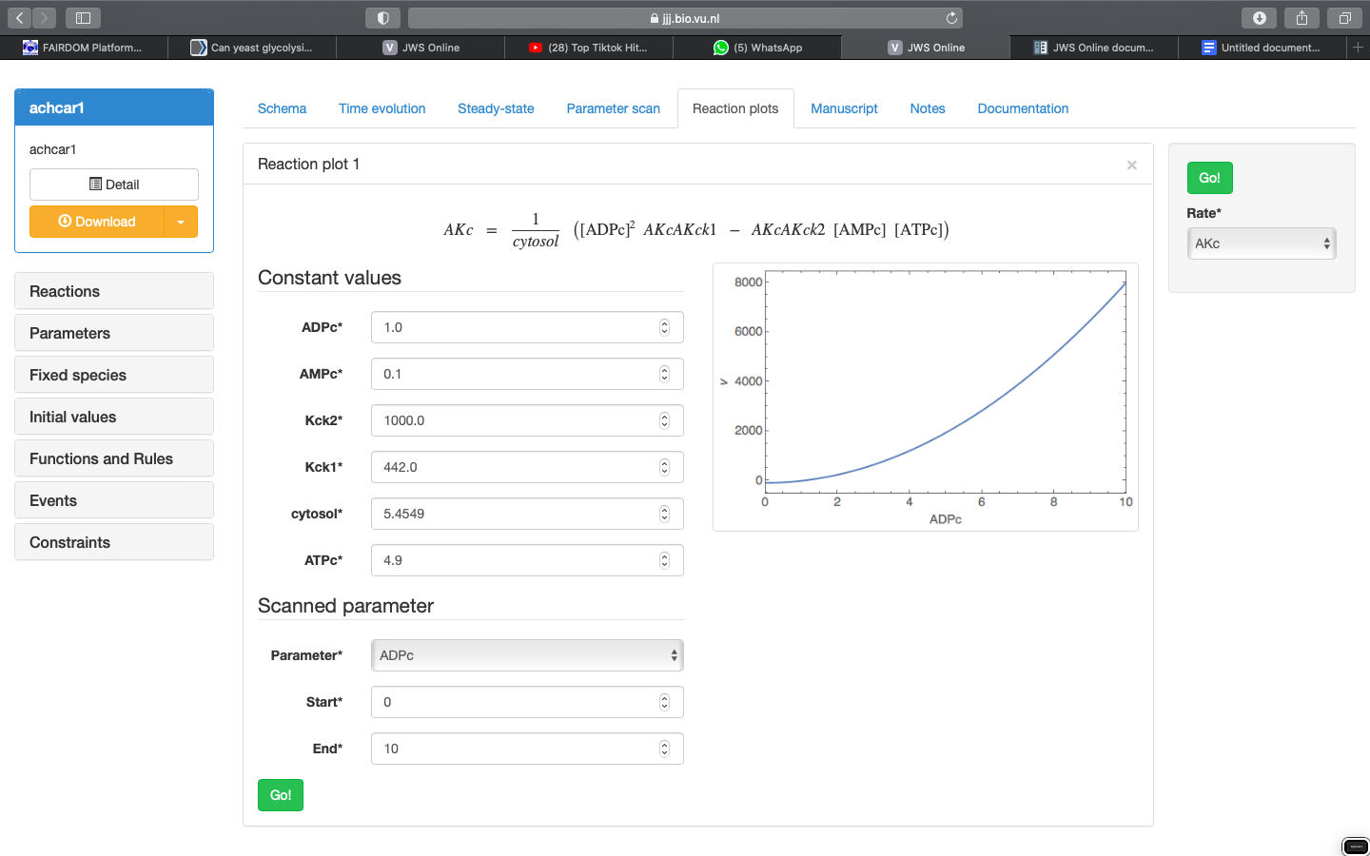

The model simulation page loads with a schematic representation of the current model. This page is where all of the available analyses are performed including:

**5.TIME EVOLUTION**

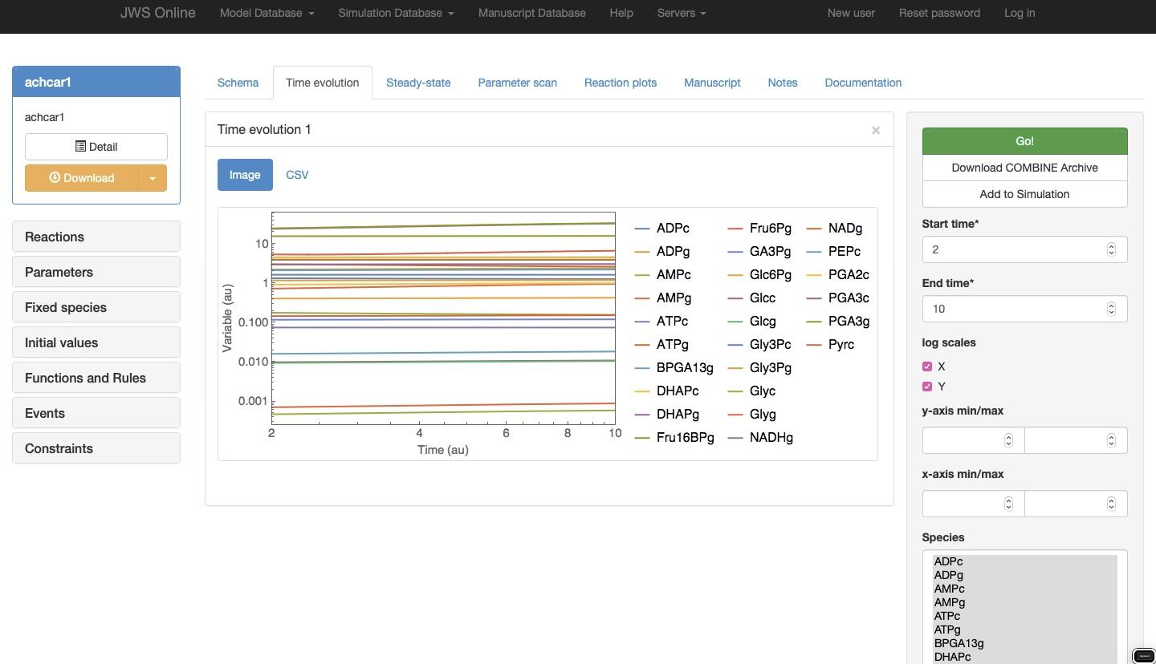**6.Steady state and Control analysis:**

Clicking on the Steady-state tab will take you to the steady-state analysis page.

Steady state: If the model is capable of achieving a steady-state flux (∂s∂t=0∂s∂t=0) this button will return the steady-state concentrations and fluxes.

Jacobian matrix: returns the matrix of all first-order partial derivatives of the system variables.

Eigenvalues: returns the eigenvalues of the Jacobian matrix

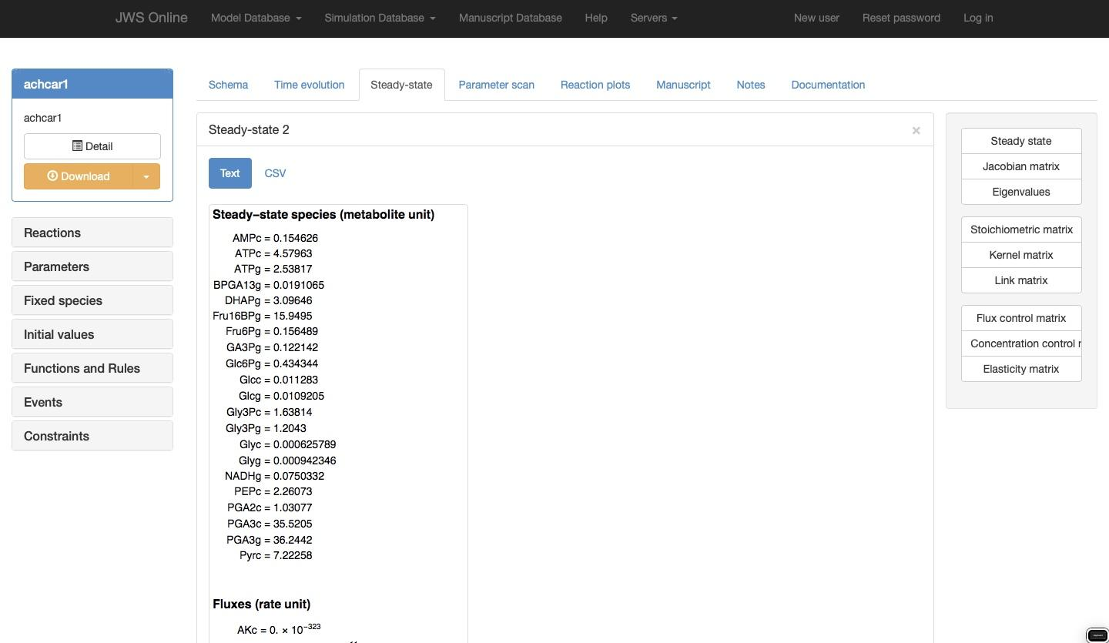

**7.PARAMETER SCAN:**

In the Parameter scan section, you are able to perform a scan of the effect of an individual model parameter on a selection of steady-state variables. In the control box on the right you will be able to specify a parameter to scan, the desired scan values (start, end, steps), and the output variables (Species, Rates, Assignment rules) to plot. Clicking ‘Go’ will perform the scan and display the results in a new result panel.

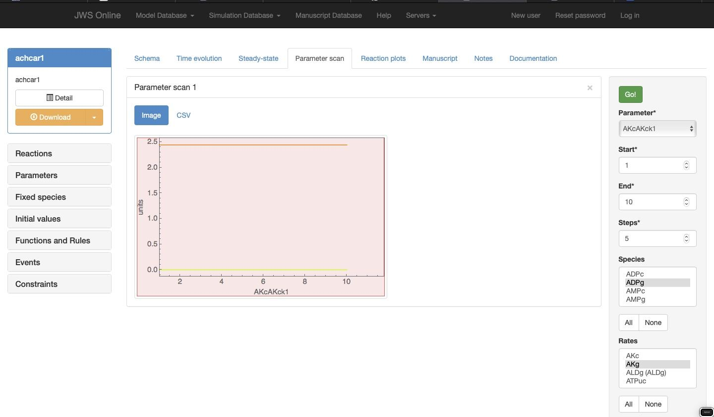**8.MANUSCRIPT**

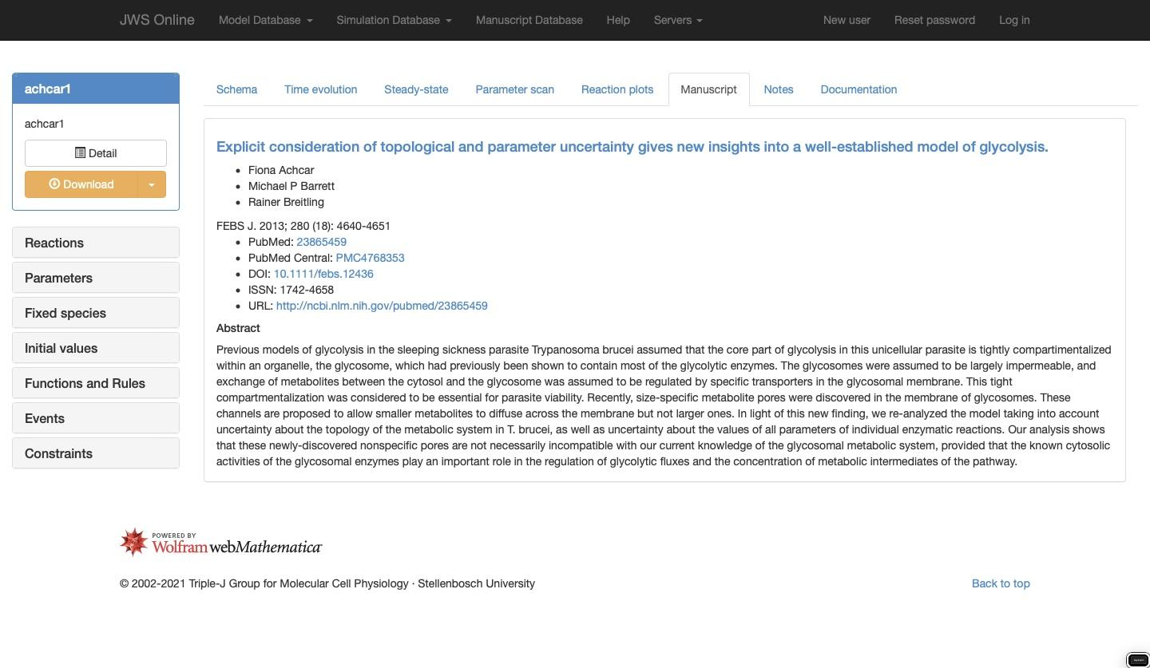

**9.DOCUMENTATION:**

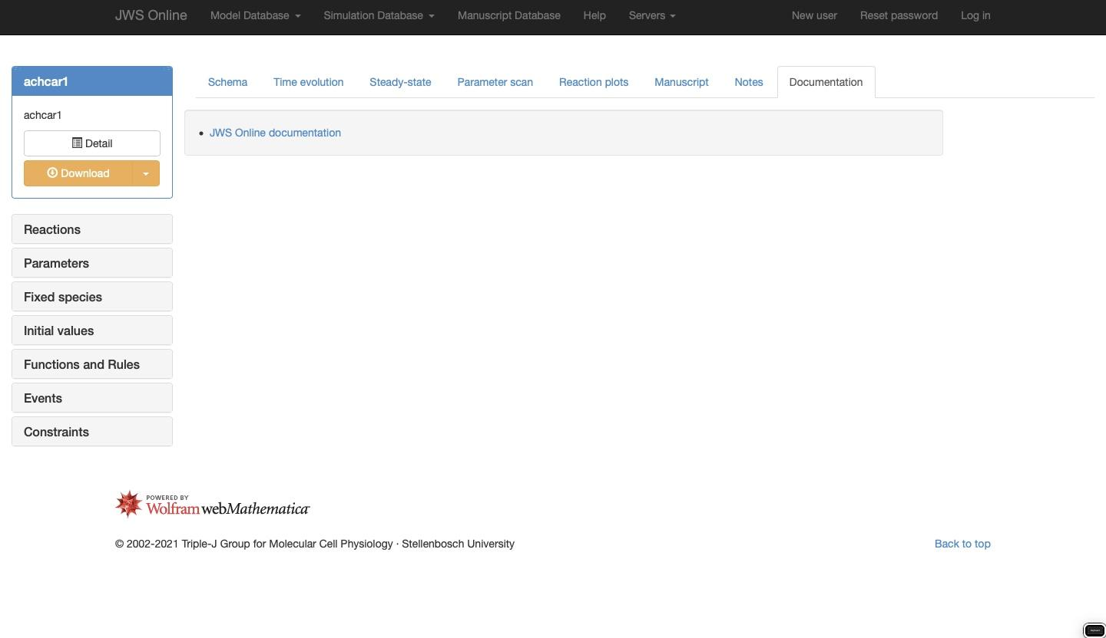

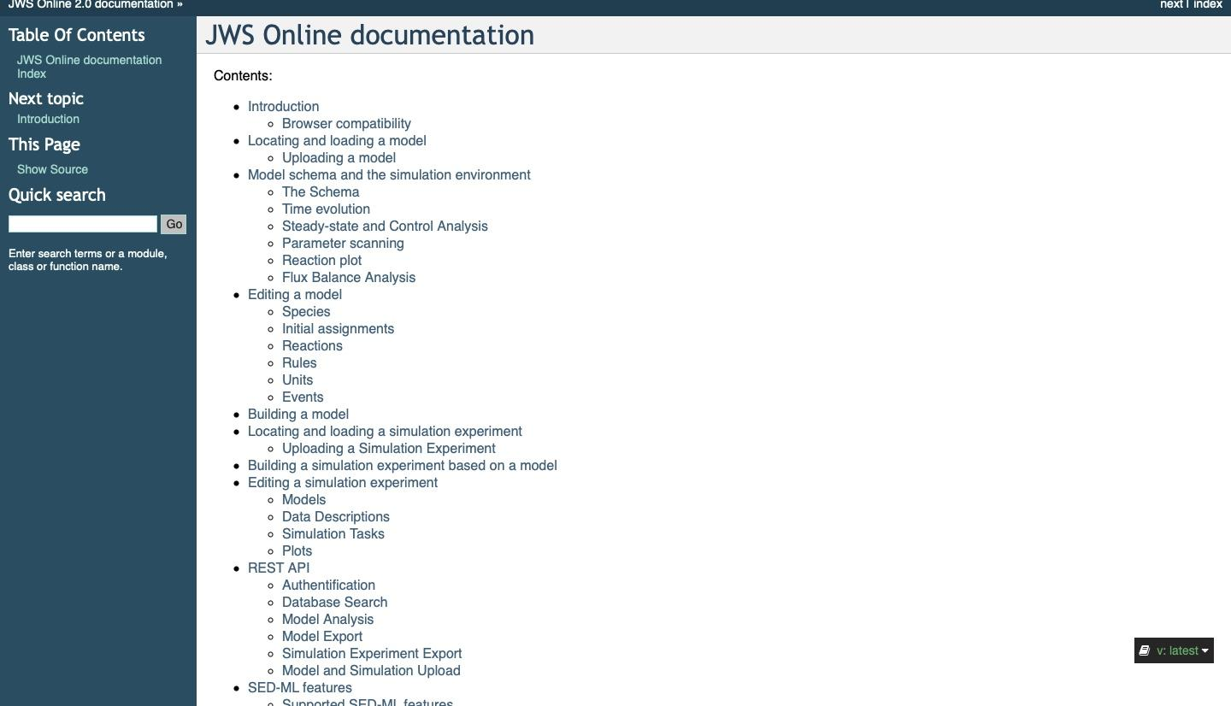

**EXPERIMENT -6**

**AIM:** To explore the Brenda Database and search for all the glycolytic enzymes.

URL - <https://www.brenda-enzymes.org/index.php>

**Q1. What is BRENDA database?**

BRENDA (BRaunschweig ENzyme DAtabase) is a comprehensive relational database on functional and molecular information of enzymes, based on primary literature.

* The database contains information extracted and evaluated from approximately 46 000 references, holding data of at least 40 000 different enzymes from more than 6900 different organisms, classified in approximately 3900 EC numbers.
* BRENDA was created at the former German National Research Center for Biotechnology (GBF, now HZI, Helmholtz Zentrum für Infektionsforschung, Braunschweig, Germany) in 1987.
* First online version in 1998 via the SRS system at the EBI.
* BRENDA is an important tool for biochemical and medical research covering information on properties of all classified enzymes, including data on the occurrence, catalyzed reaction, kinetics, substrates/products, inhibitors, cofactors, activators, structure and stability.
* 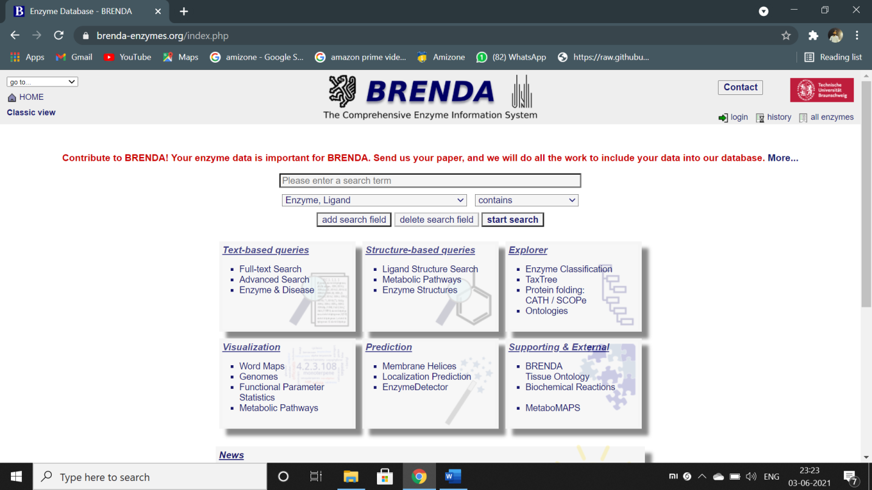

Figure – home page of Brenda database

**Q2. What is EC number?**

**Ans.** Enzyme Commission numbers (EC Numbers) are defined according to the catalyzed reaction

by the IUBMB (International Union of Biochemistry and Molecular Biology). The enzymes are classified according to the Enzyme Commission list of enzymes. Some 6500 "different" enzymes are covered. Frequently enzymes with very different properties are included under the same EC number.

**Q3. What types of information provided by BRENDA?**

**Ans.**  Information that we get from the BRENDA database are :

* Enzyme and ligand nomenclature
* Organisms
* Reaction and specificity
* Kinetic energy
* Structure and role of ligand
* Stability information
* Ligand - enzyme information
* Enzyme sequence and structure
* Mutants and disease
* Occurrence, isolation and properties

**Q4. What are the different types of search features provided in the BRENDA database?**

**Ans.** BRENDA is stored as a relational database, containing all data in 46 tables, enabling different queries. Different search features provided in BRENDA are:

* The quick search mode provides easy access to the data of each information field individually. The search results are displayed in a comprehensive table format and also as a compact printable version. The table version includes links to a reference-specific view, pictures of molecules functioning as ligands, Gene Ontology (GO) definitions, PDB entries, amino acid sequences and cross-references to other databases.
* The advanced search mode allows one to combine 25 different query criteria. In addition to the possibility of restricting the query to a unique organism, the search can be extended to an upper level of a branch of the BRENDA taxonomy tree (TaxTree).
* The BRENDA TaxTree is based on the tree published by the NCBI. The TaxTree search allows users to browse and search for organism names or nodes in the NCBI taxonomy browser. In addition, a search can be performed on organisms that are stored only in BRENDA but do not occur in any sequence database. Special features show the availability of data for a specific organism class or organism in BRENDA.
* The ECTree in BRENDA displays the enzyme classification as defined by the IUBMB.

**Home Page:**

**Searching for following enzymes :-**

**1. Protease**

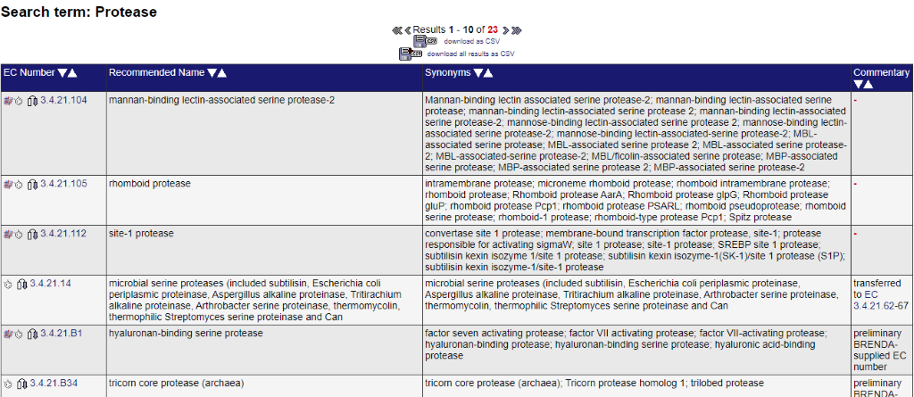

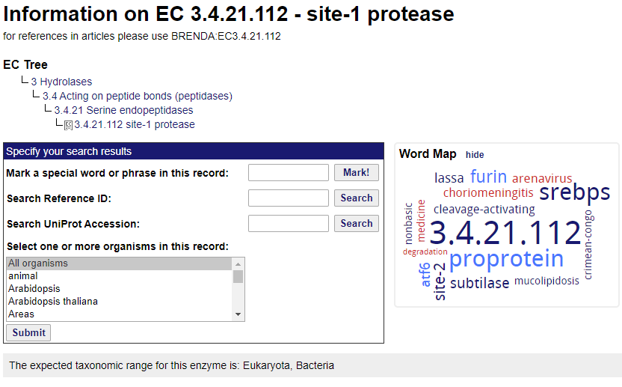

The enzyme appears in viruses and cellular organisms. **Protease** refers to a group of **enzymes** whose catalytic function is to hydrolyze peptide bonds of proteins. They are also called **proteolytic enzymes** or proteinases.

There are various parameters mentioned.

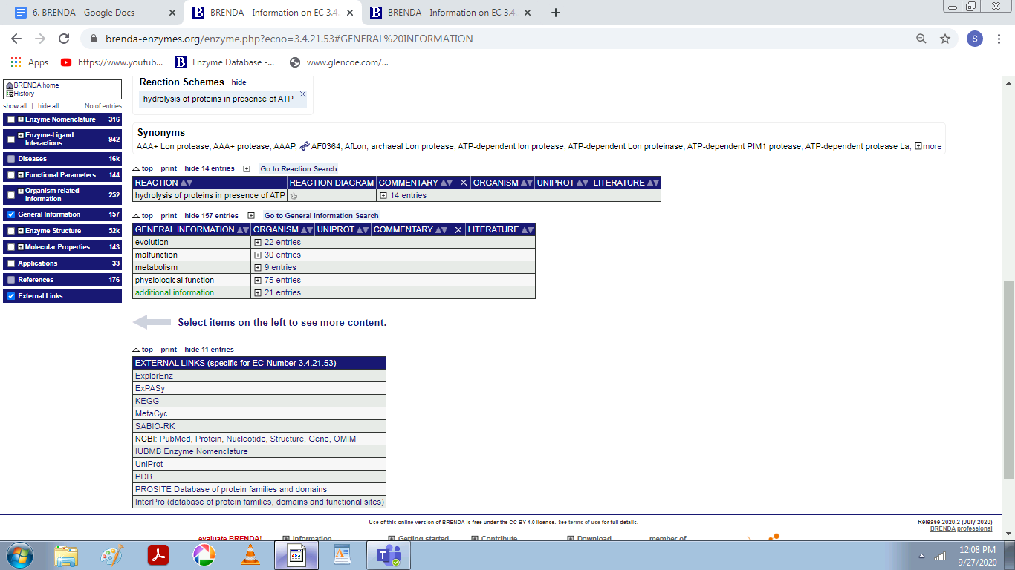

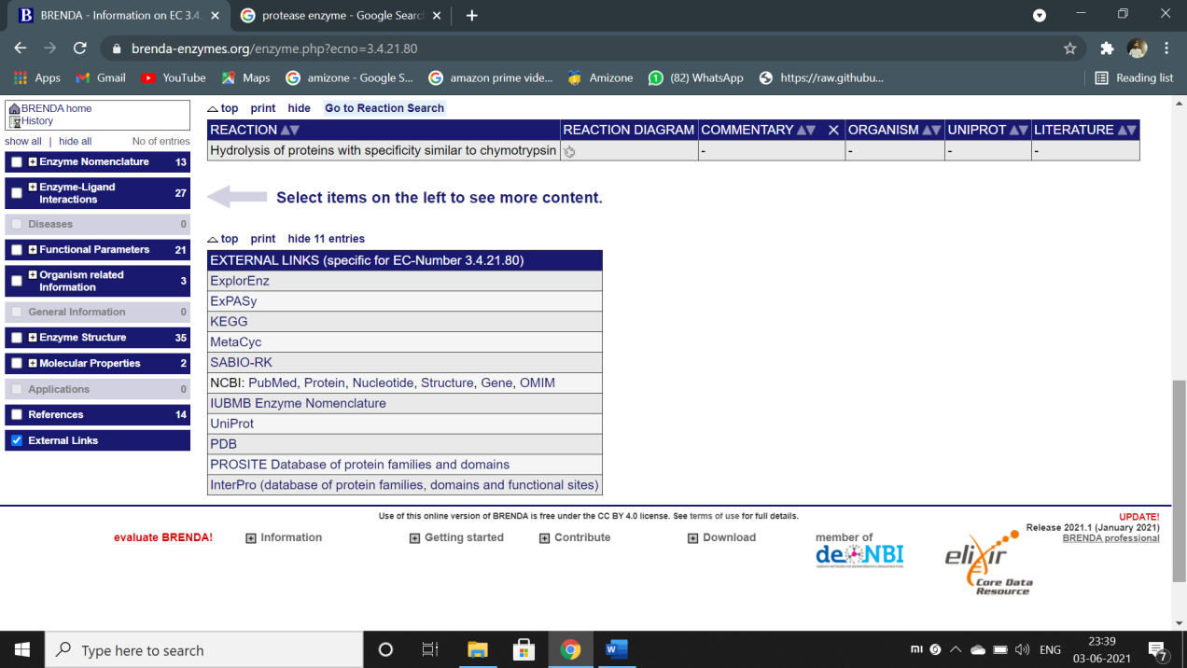

**Figure – external links to refer to other databases.**

**2. LIPASE**

**Lipase**, any of a group of fat-splitting enzymes found in the [blood](https://www.britannica.com/science/blood-biochemistry), gastric juices, pancreatic secretions, intestinal juices, and adipose tissues. Lipases hydrolyze [triglycerides](https://www.britannica.com/science/triglyceride) (fats) into their component [fatty acid](https://www.britannica.com/science/fatty-acid) and [glycerol](https://www.britannica.com/science/glycerol) molecules.

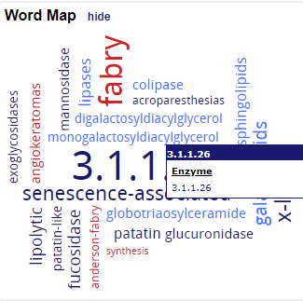

The enzyme appears in viruses and cellular organisms

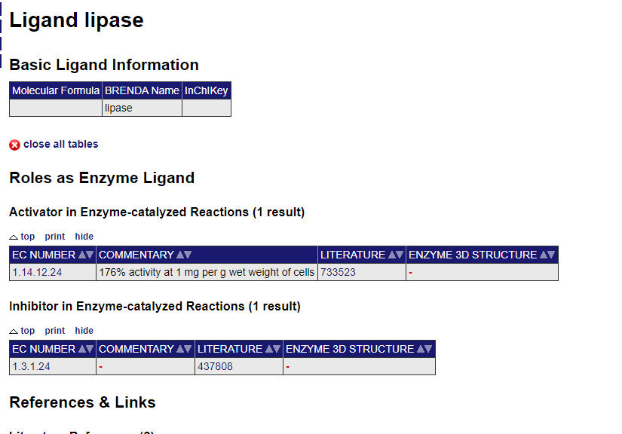

There are various external links and references in BRENDA. There are journals authors mentioned for each reference.

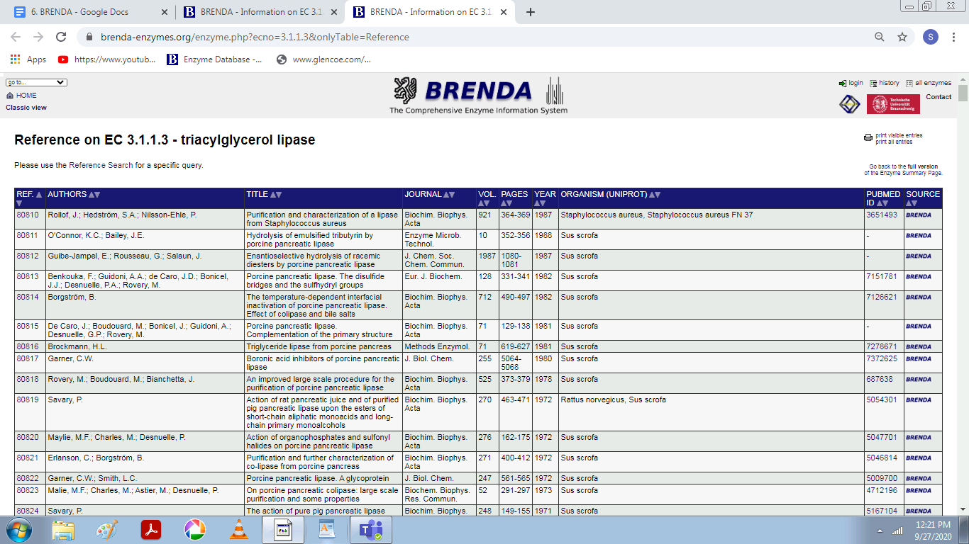

**3. DNA POLYMERASE**

A DNA polymerase is a member of a family of enzymes that catalyze the synthesis of DNA molecules from nucleoside triphosphates, the molecular precursors of DNA. These enzymes are essential for DNA replication and usually work in groups to create two identical DNA duplexes from a single original DNA duplex.

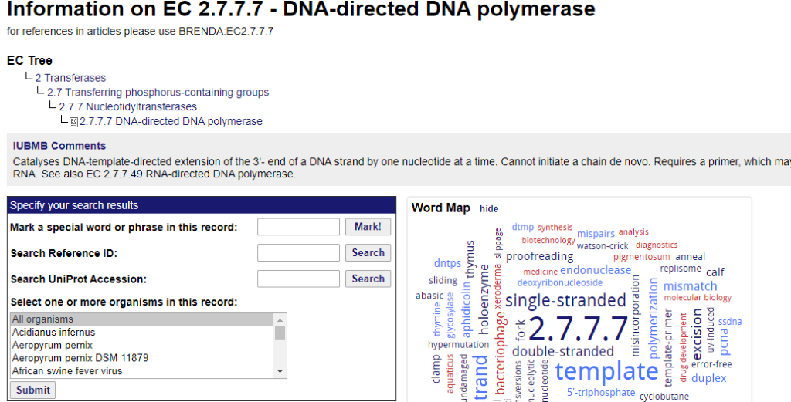

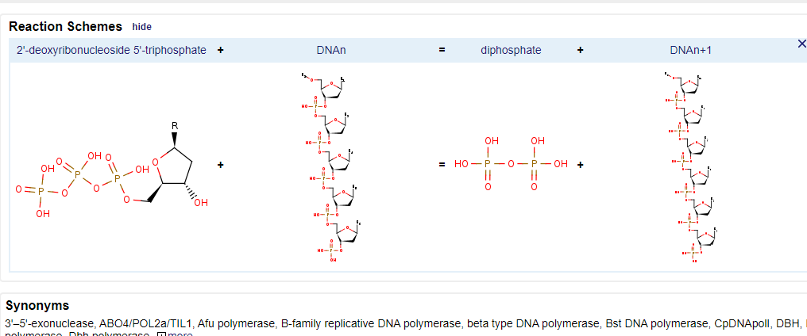

**4. DNA LIGASE**

DNA ligase is a DNA-joining enzyme. If two pieces of DNA have matching ends, ligase can link them to form a single, unbroken molecule of DNA.

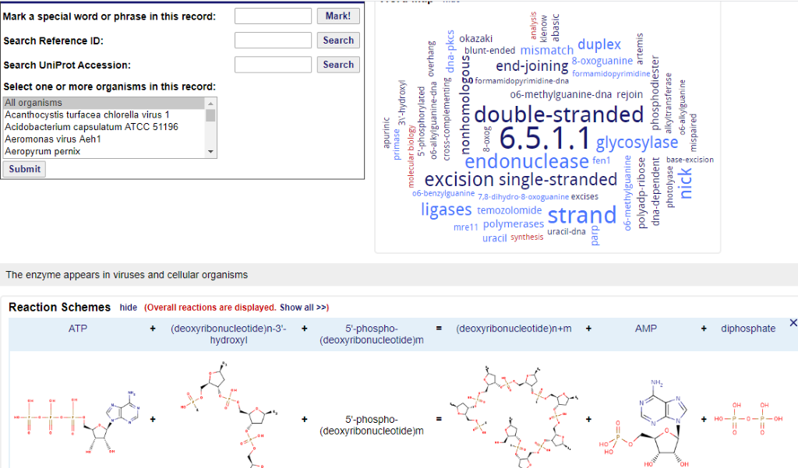

**5. SUCRASE**

Sucrase, also called Invertase, any member of a group of enzymes present in yeast and in the intestinal mucosa of animals that catalyze the hydrolysis of cane sugar, or sucrose, to the simple sugars glucose and fructose.

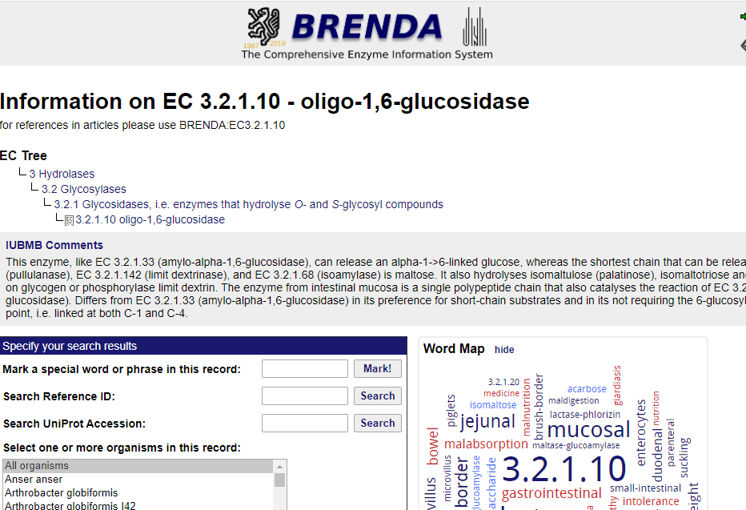

**6. AMYLASE**

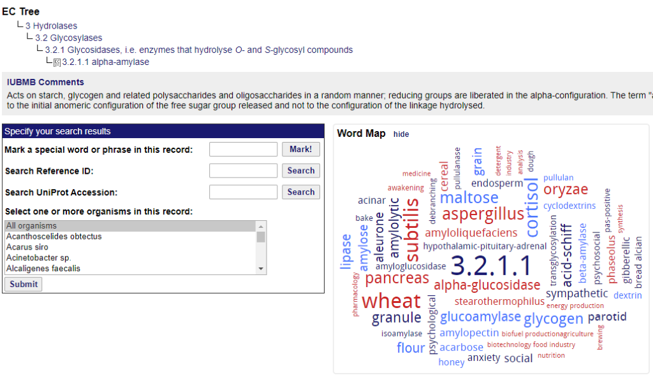

**6. TRYPSIN**

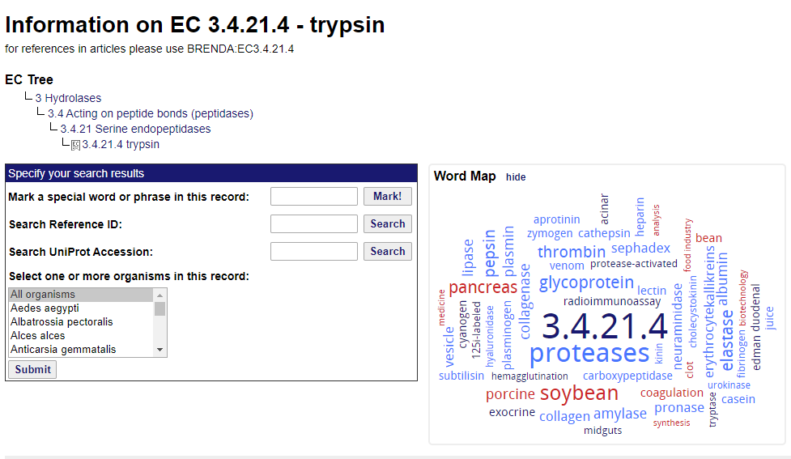

**Insilico system Biology**

**Laboratory file**

**Experiment 7 – to study the model organism using SABIO RK.**

**Submitted by – Meenu Dhama**

**Roll no. – 004**

**EXPERIMENT 7**

**Aim:** To search data and models of yeast glycolysis in SABIO-RK database

**URL:** http://sabio.h-its.org/

**THEORY:** SABIO-RK is a curated database containing structured information about biochemical reactions and their corresponding kinetics. It describes participants and modifiers of the reactions, as well as measured kinetic data (including kinetic rate equations) embedded in their experimental and environmental context. The system offers standardized data for metabolic and newly also signaling reactions by the use of controlled vocabularies and annotations pointing to other resources and biological ontologies. It enables the access to kinetic data for experimentalists and modellers. Thereby, SABIO-RK facilitates the exchange of the data between experimentalists and modellers, supporting the setup of quantitative computer models.

**PROCEDURE:**

* The Search field offers free text search.

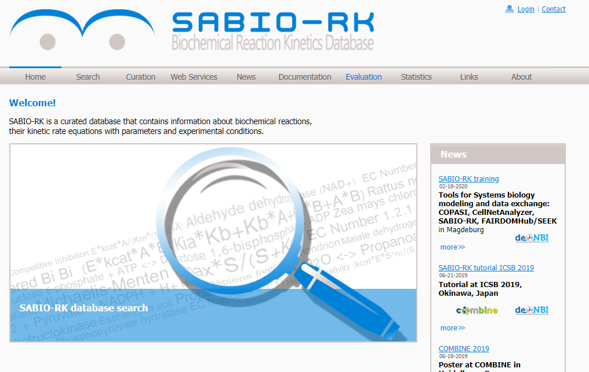

* The search result is represented by default in the Entry View, which is a table containing overview information of the database entries sorted by Sabio EntryID.
* We take reaction of Saccharomyces cerevisiae.

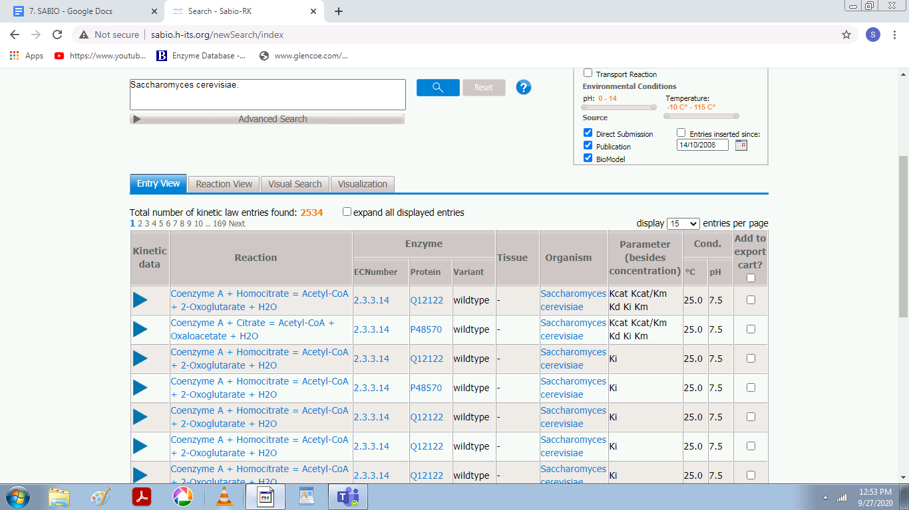

* Detailed information is given in the single database entries which can be displayed by clicking on the blue triangle to open an entry. Alternatively all entries can be opened at once by selecting “expand all displayed entries”.

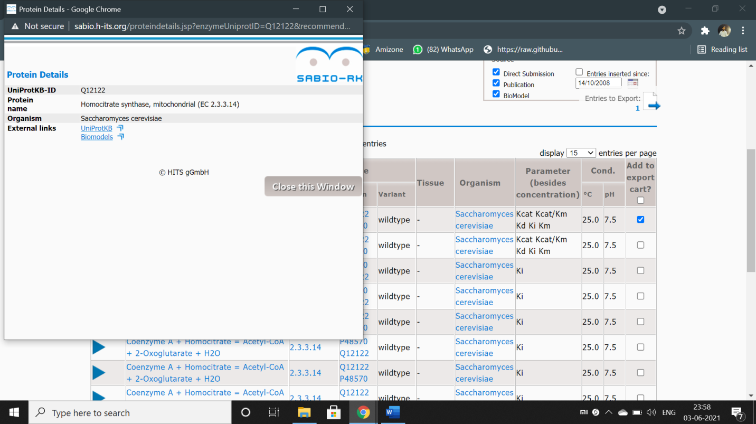

Figure – details about the protein.

* Now to see the reaction view we click on reaction view and then we click on the “click here to visualise option”.
* By clicking on each option, we can see details about themindividually.

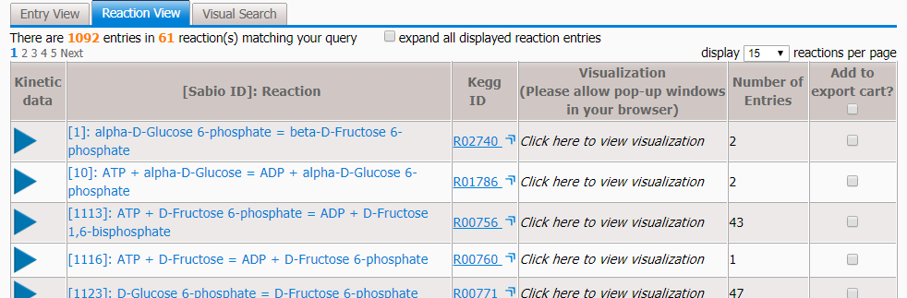

* Reaction View table which groups the entries based on the biochemical reaction.
* To get a quick impression about a certain reaction and to understand the connections between reaction, enzymes, organisms, and tissues a visualization is available.

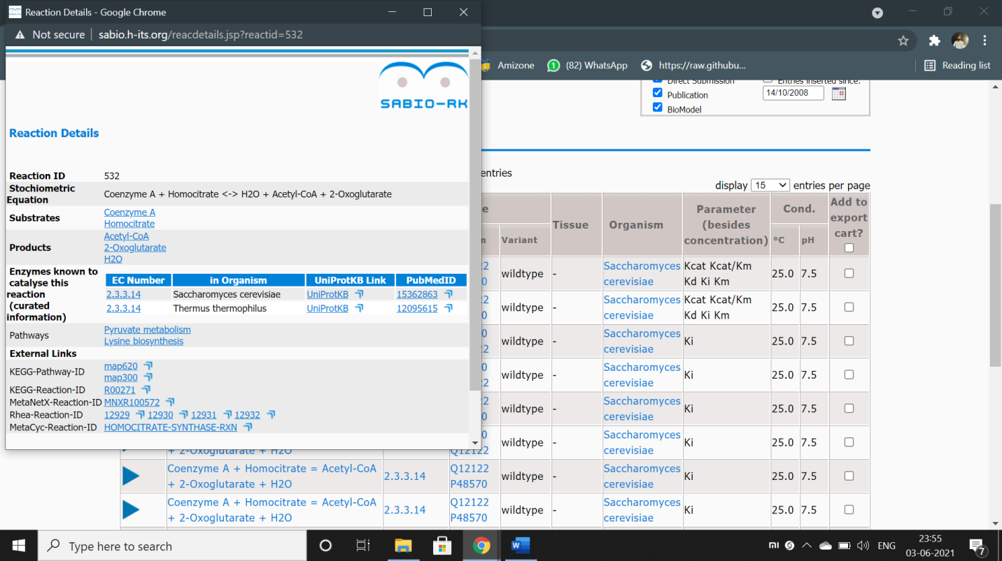

**Visual Search:**

Finally Visual Search gives a visual overview of the Search Result together with the opportunity to confine the search, e.g. to an organism, a tissue or a special kind of kinetic parameter or kinetic rate law.

There are various parameters taken into account and can observe them in “Visual Search”.

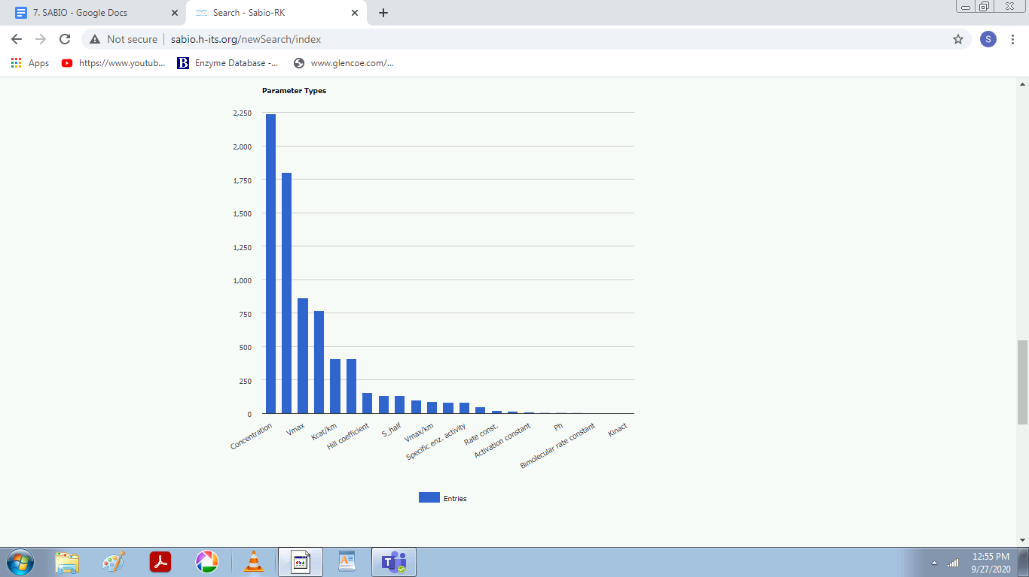

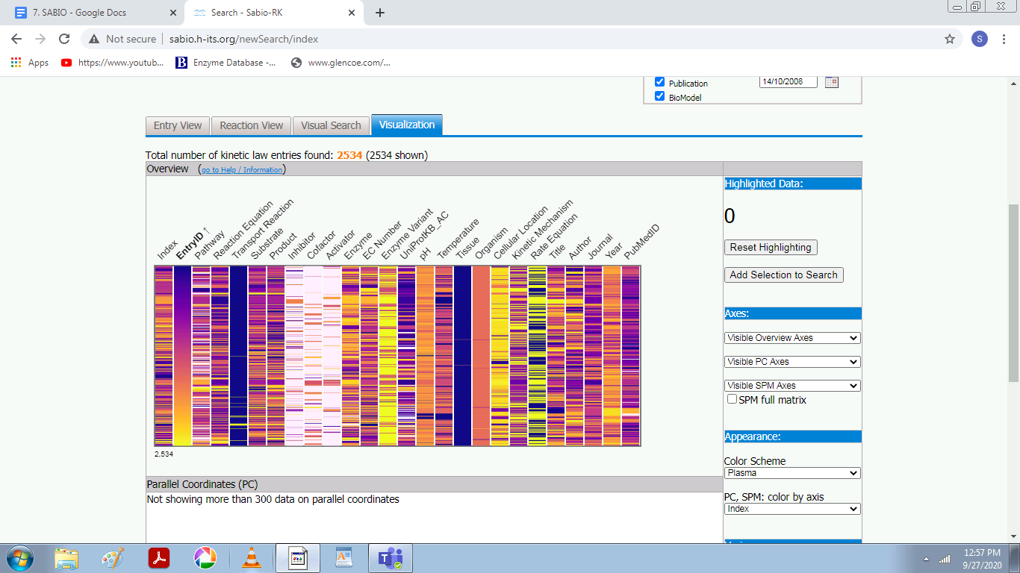

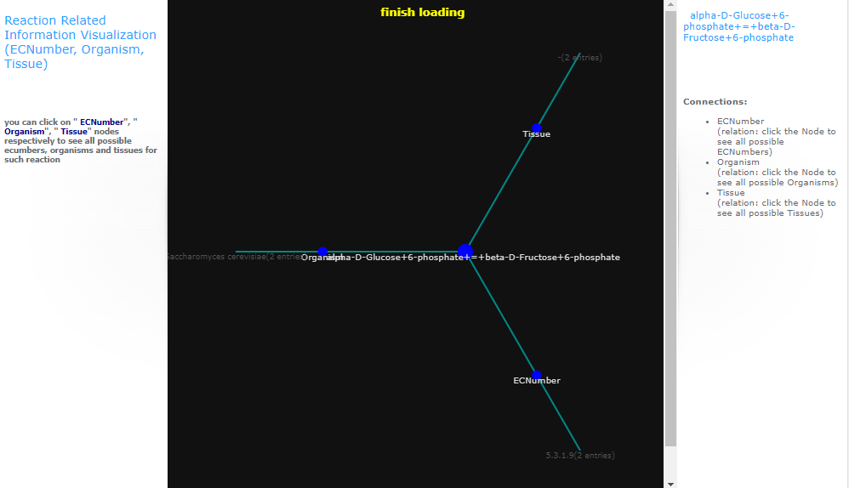

**Data Export:**

* To export data in SBML, BioPAX, or spreadsheet format entries can be selected either in the Entry View or Reaction View by clicking the checkbox.
* Selected entries are stored in the Export Cart.

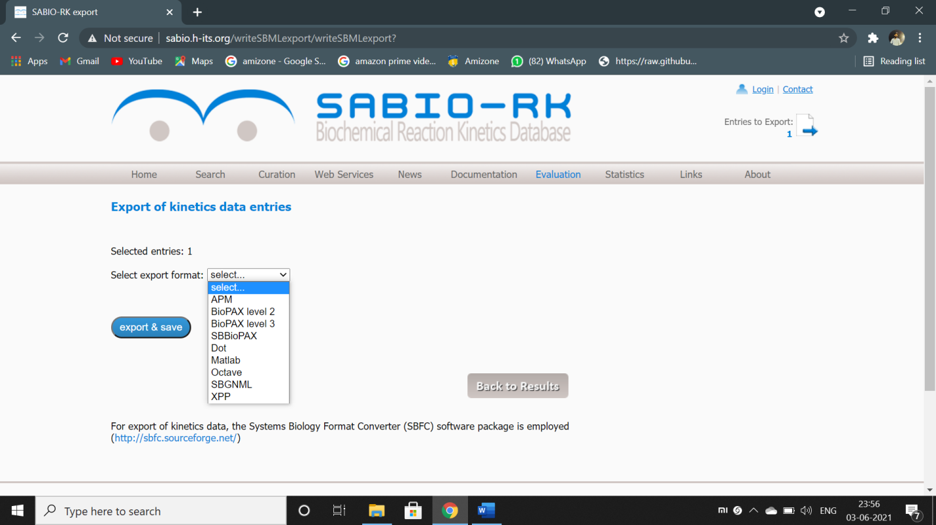

Figure – data export formats supported by SABIO RK.

* By clicking on “Entries to Export” a table gives an overview about selected entries for export in SBML, BioPAX or spreadsheet format.

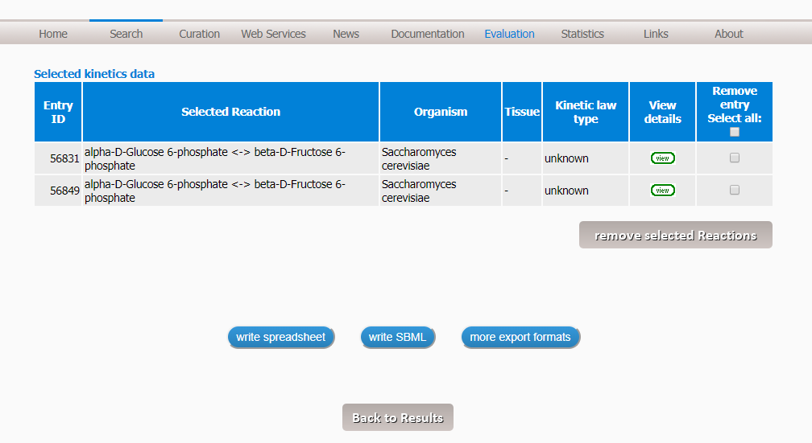

There are three different exports methods: Write spreadsheet, SBML, and BioPAX

**Write spreadsheet** allows to export the data in a table format (xls or tsv).

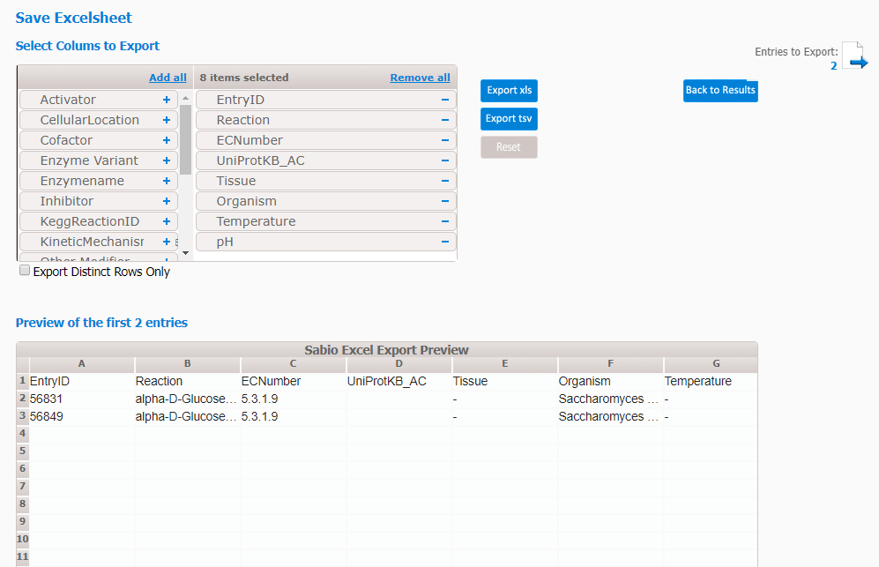

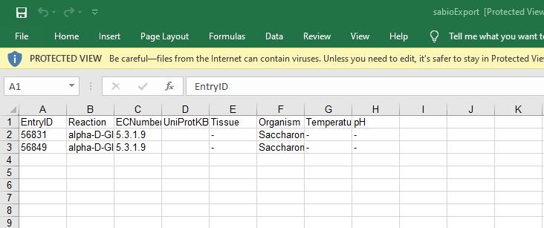

**Write SBML** allows to export the selected entries as a model in the Systems Biology Markup Language (SBML)-format or as pdf. Different SBML versions and annotation schema could be selected and a user-defined name could be given to the SB 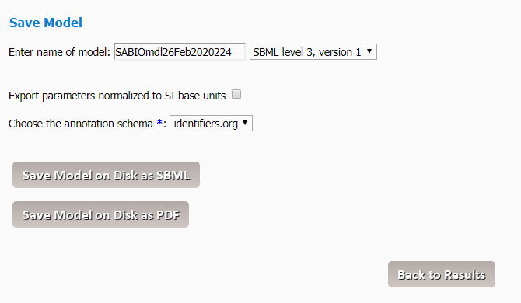

**EXPERIMENT 8**

**AIM:** To download and study the SBML file of yeast glycolysis by Teusink B. et al from BioModels database (BIOMD0000000064)

SBML definition:

Systems Biology Markup Language (SBML) is a xml (eXtensible Markup Language) based language. It is a description language for simulations in systems biology. SBML is suitable for representing biochemical networks, which includes cell signaling pathways, metabolic pathways, biochemical reactions, gene regulation, and many others. It is a represented format of computational models. Modeling process involves the following steps. SBML allows models of uniformed complexity to be represented. Each type of model is described using a specific type of data structure which organizes the relevant information. The data structures conclude how the resulting model is encoded in XML.

Levels in SBML:

In SBML Level 1 Version 2, the term specie has been replaced with the species throughout the speciﬁcation. Models written in SBML Level 1 Version 2 format should use the new spelling. SBML Level 1 Version 2 should accept both spellings on input for all elements and attributes where the term occurs. Each species in the pathway is replaced by species id ,like in glycolysis glucose can be represented as [S1]. In this level, all the enzymes are represented away from the reactions [mentioned separately].

In SBML Level 2, the species spelling will be removed entirely and only species will be used. Finally, note that the deﬁnition of Species in SBML requires a species in a model to be located within a compartment. That compartment should define any species. One exception in this case is degenerative models does not have any species or reactions.

SBML Level 1 supports non-spatial biochemical models and the operations that are possible in existing analysis or simulation tools. The potential features that have been intentionally omitted from the language deﬁnition in Level 1. We expect that subsequent release of SBML will add the possible features which are not included in Level1. As mentioned above, SBML Level 1 provides the most basic foundations for modeling biochemical networks. Some of the signiﬁcant features that are missing from Level 1; these will be included in the next Level of SBML.

In SBML, level 3 is defined as a latest version which is having a defined core set of features and optional packages adding features to the core. In this approach model can declare which feature sets they use and software tools they can declare which packages they support. SBML Level 3 package development is today an ongoing activity

The additional features that are likely be included in SBML Level 2 or 3 are Arrays, connections, Database Interoperability, Geometry, Submodels, component Identification, References, Diagrams.

Example of SBML file format is shown below.

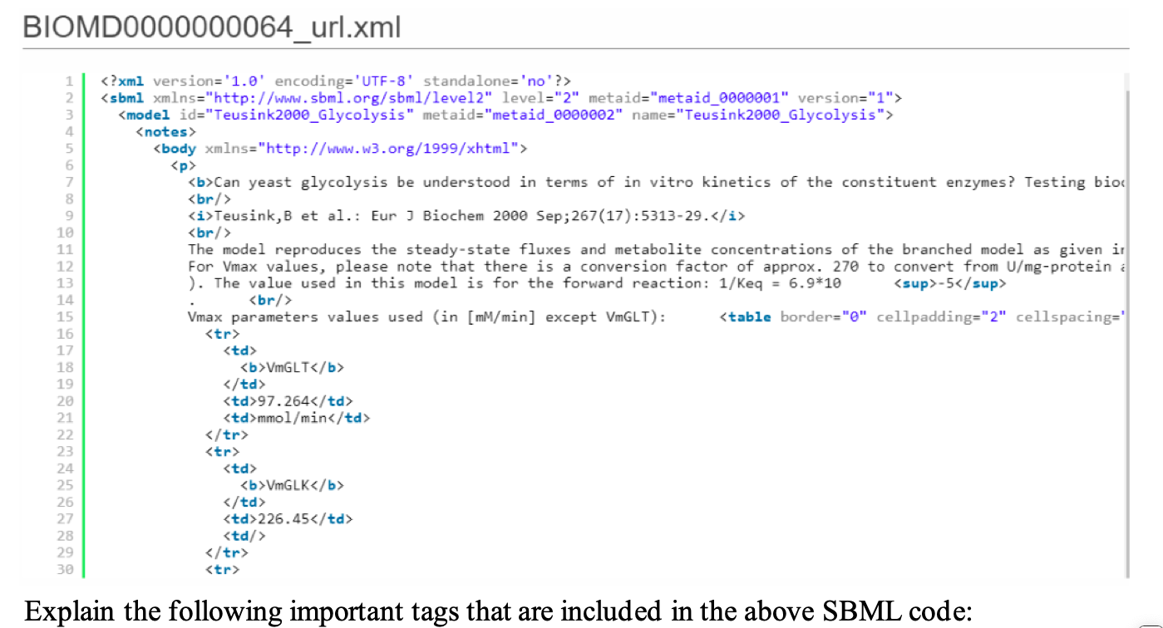

**Body**: It defines the information and details about the model.

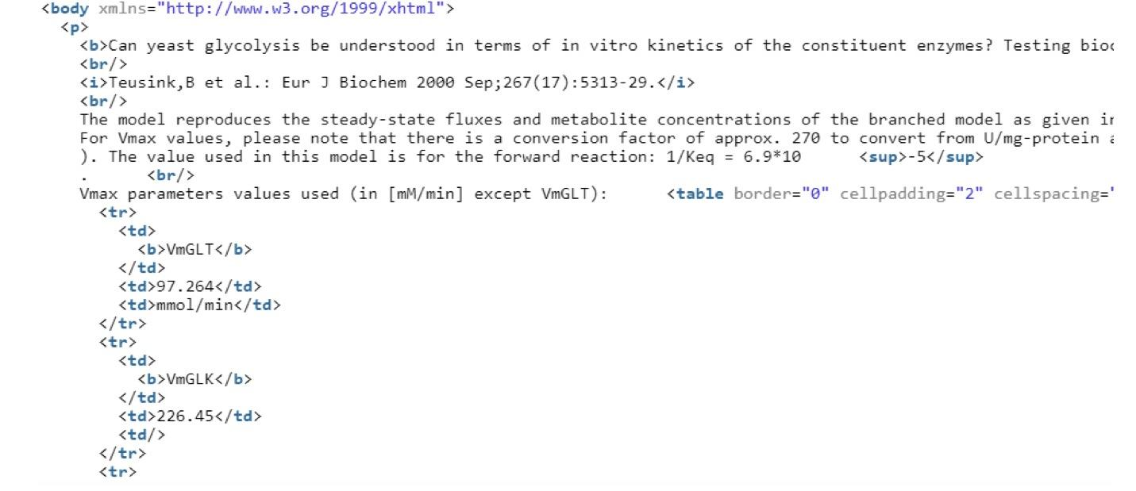

**End of the body:**

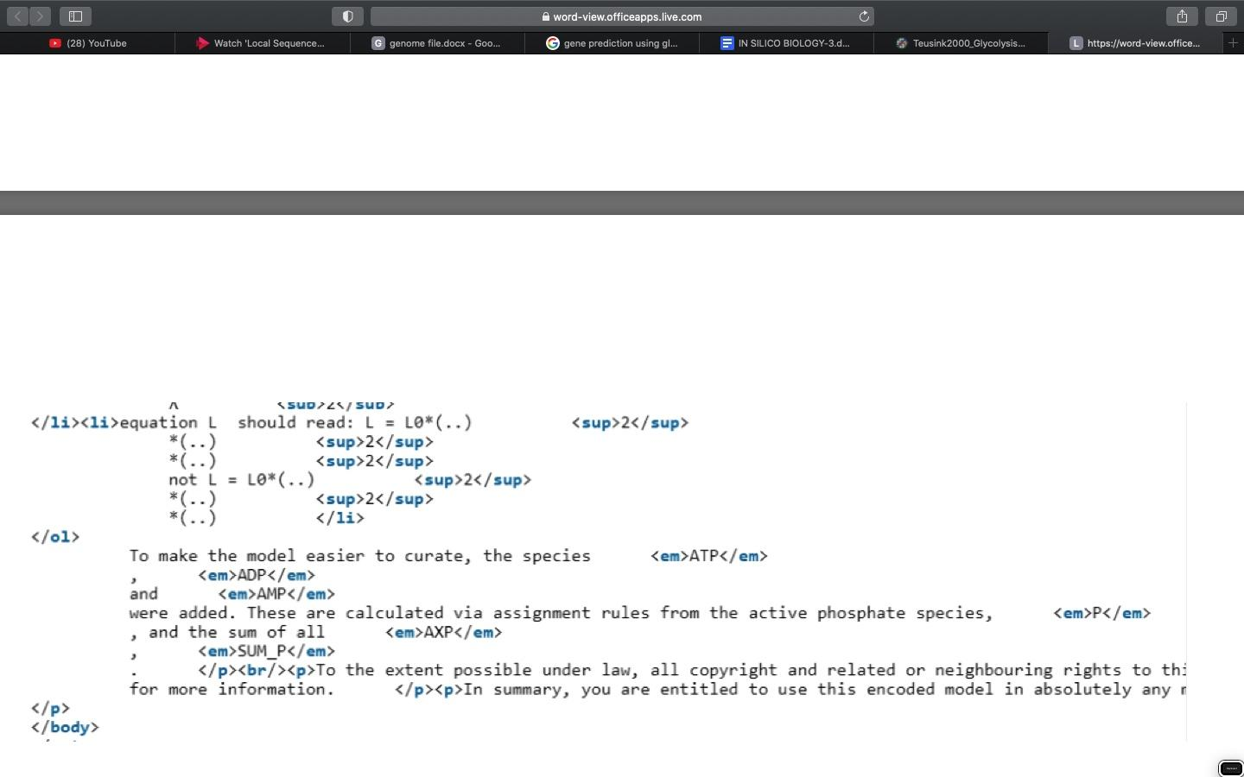

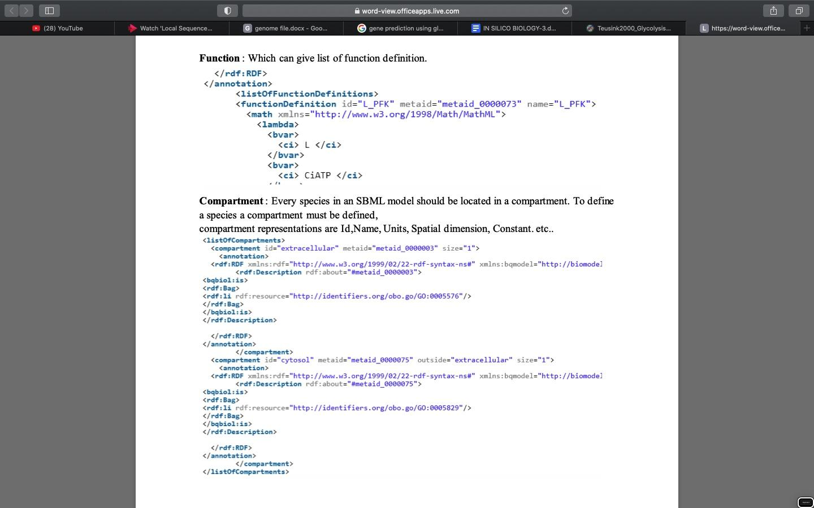

**Species: It corresponds to the objects or substances in the model.**

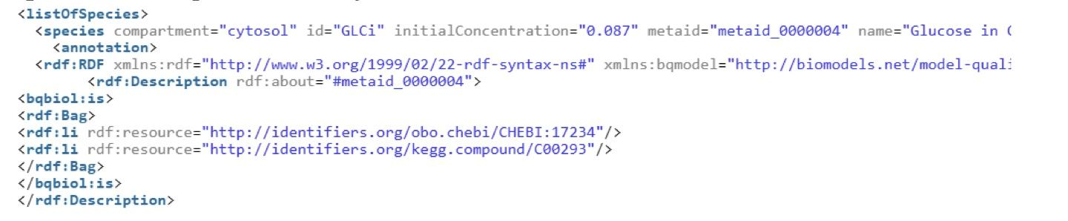

**Parameters : It represents the different parameters required to develop a model.**

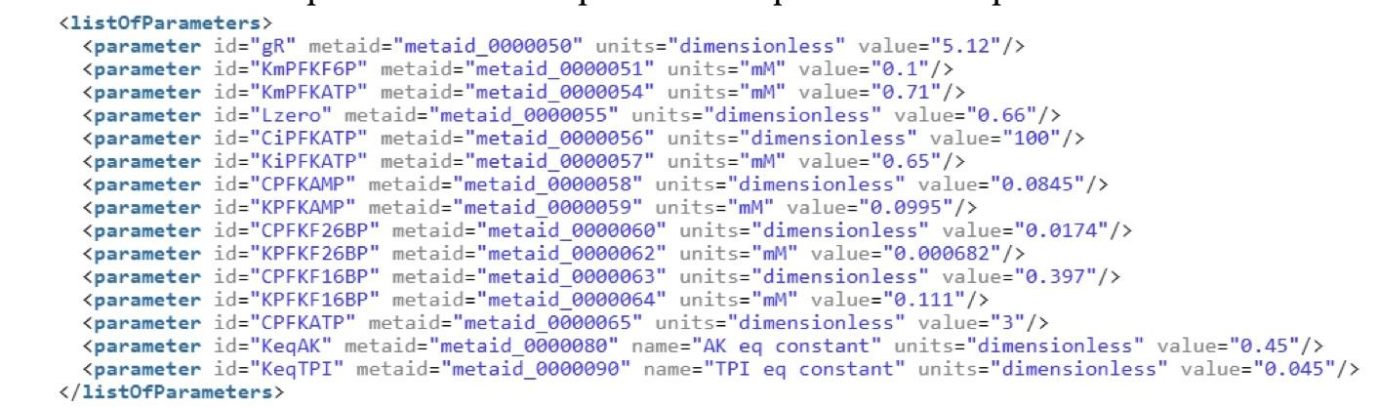

**RULES:**

1. **Rate rule:**

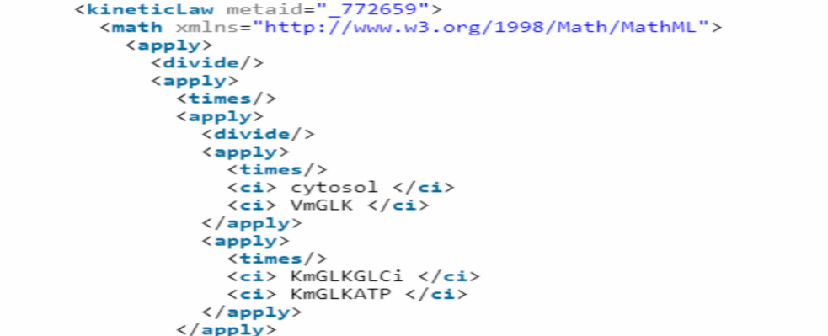

1. **Algebraic rule**

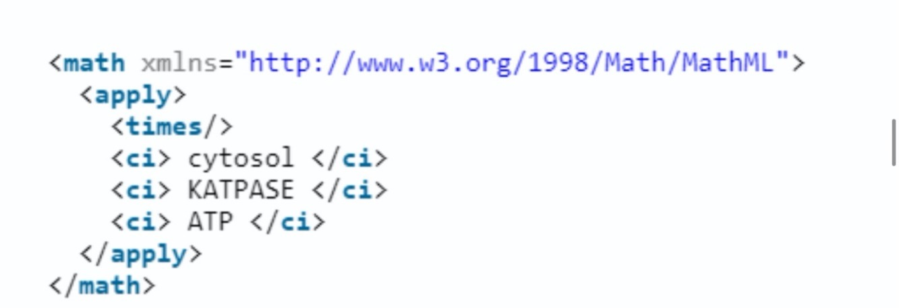

**3.Assignment rule :** 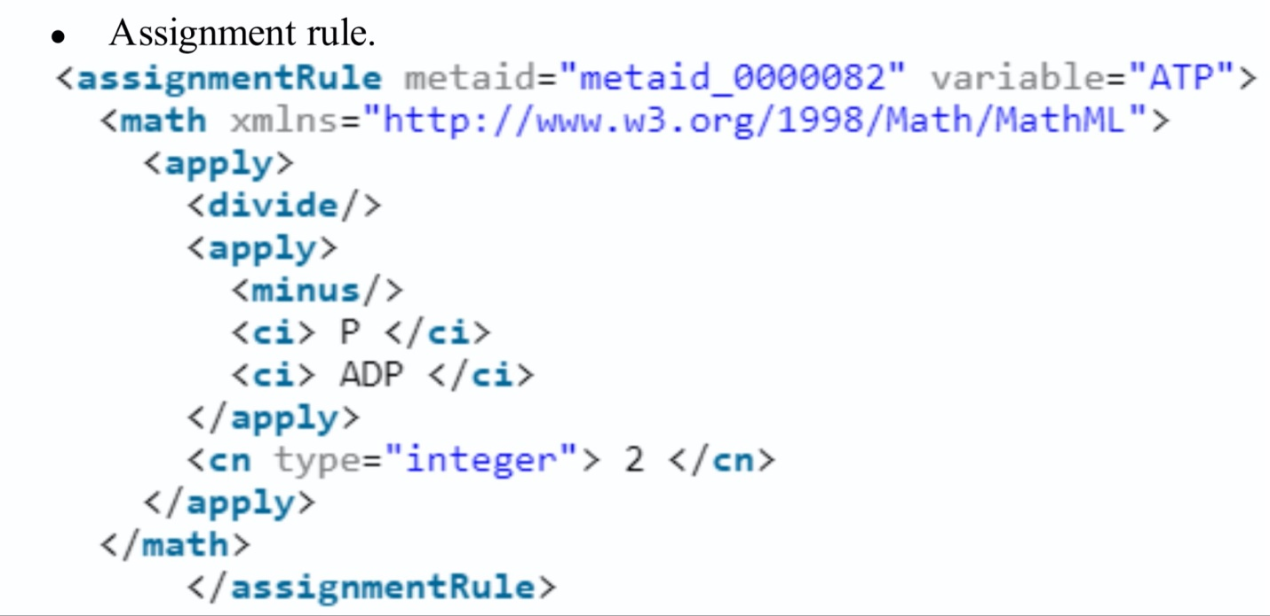

**REACTION:**

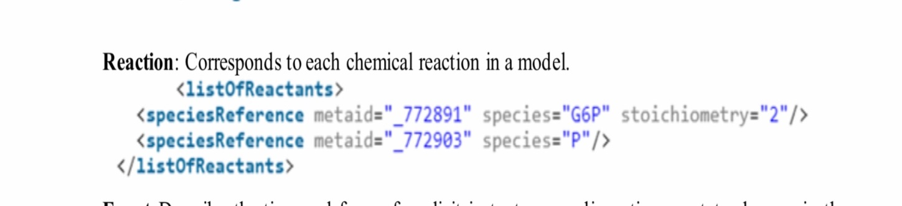

**Event:** Describe the time and form of explicit instantaneous discontinuous state changes in the model.

**Product:** It describes the end product of the reactions in the model.

**Modifier**: Represents the enzymes ( inhibitor / catalyst)

**EXPERIMENT – 9**

**AIM:** To explore *E. coli* metabolic model in MetaNetX

**MetaNetX**

**URL-** <http://metanetx.org>

**Theory-** MetaNetX.org is a website for accessing, analysing and manipulating genome-scale metabolic networks (GSMs) as well as biochemical pathways. It consistently integrates data from various public resources and makes the data accessible in a standardized format using a common namespace. Currently, it provides access to hundreds of GSMs and pathways that can be interactively compared (two or more), analysed (e.g. detection of dead-end metabolites and reactions, flux balance analysis or simulation of reaction and gene knockouts), manipulated and exported. Users can also upload their own metabolic models, choose to automatically map them into the common namespace and subsequently make use of the website’s functionality.

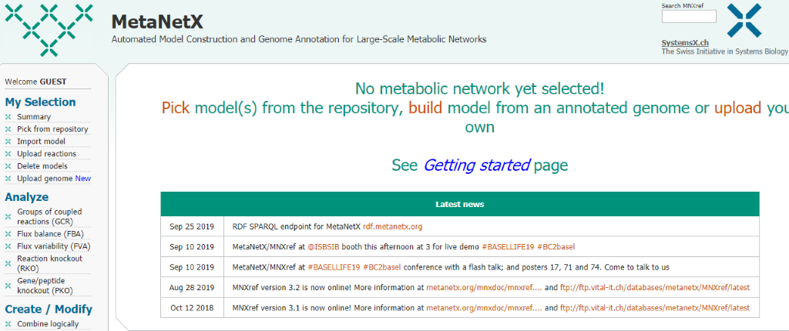

Figure – home page of MetNetx.

**Procedure-**

1. To explore E coli metabolic pathway, we first have to choose a model from the repository through pick from repository option from left column options.

2. Select the E. coli species. Any interested strain can be selected and also more than one model can also be picked.

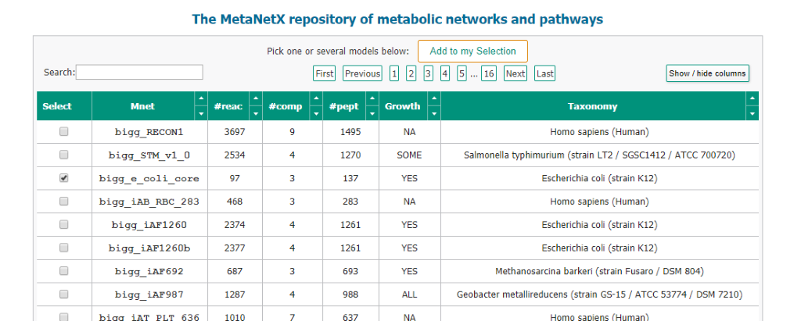

3. After selecting click on Add to my Selection button and choose the column number whose information you want to collect.

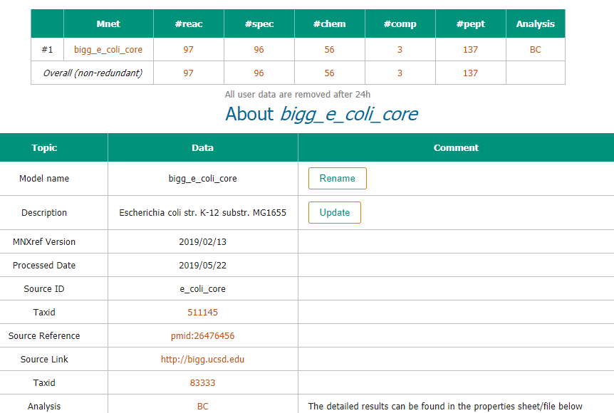

4. For the reactions involved we can choose #reac option and get the following results.

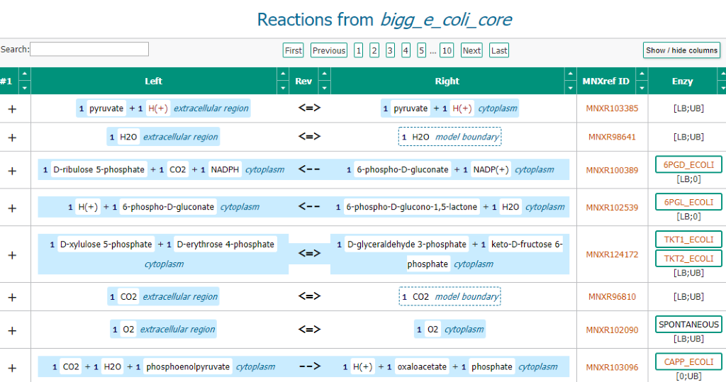

**EXPERIMENT - 10**

**AIM**: To explore BiGG Model

**URL-** <http://bigg.ucsd.edu/>

**Theory-** BiGG Models is a knowledgebase of genome-scale metabolic network reconstructions.

BiGG Models integrates more than 70 published genome-scale metabolic networks into a single database with a set of standardized identifiers called BiGG IDs. Genes in the BiGG models are mapped to NCBI genome annotations, and metabolites are linked to many external databases (KEGG, PubChem, and many more). For details about updates to the BiGG Models website and database, see the updates page and the GitHub repository.

BiGG is freely available for non-commercial use. It is hosted and maintained by the Systems Biology Research Group at the University of California, San Diego.

**PROCEDURE-**

1. In the search box, search for the interested organism or pathway or model.

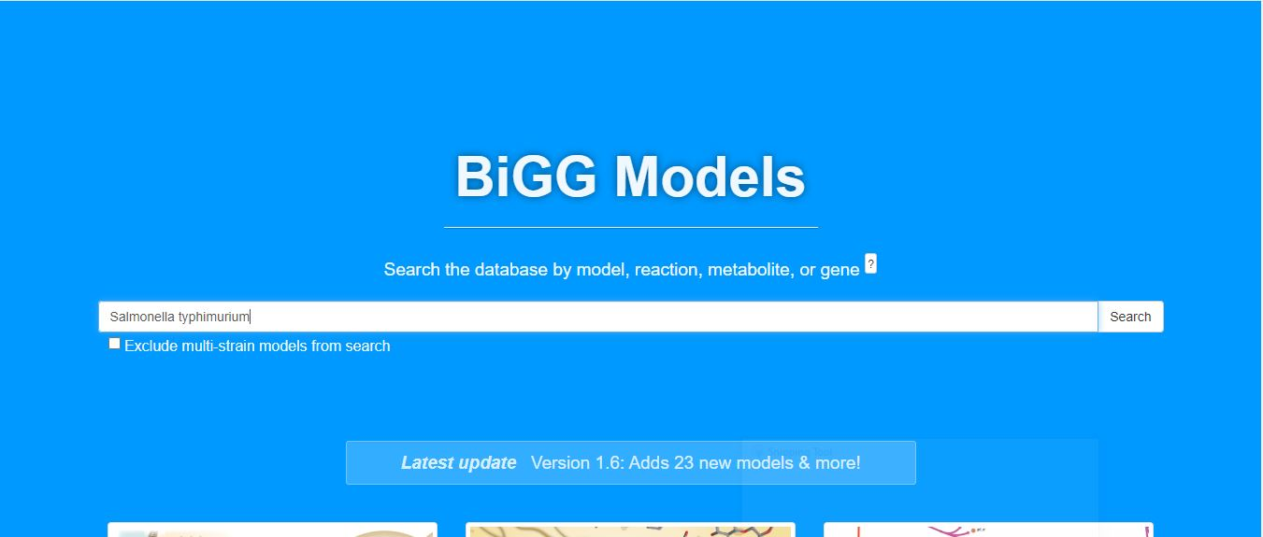

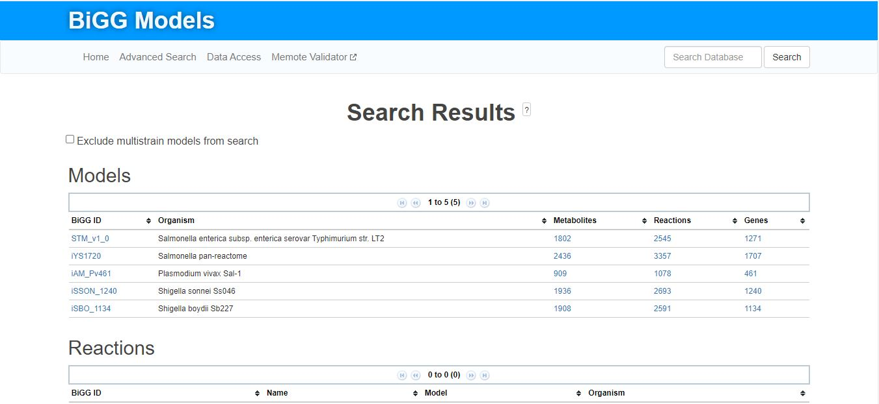2. From here, choose the interested model or metabolite or reaction you want to explore related to selected organism.

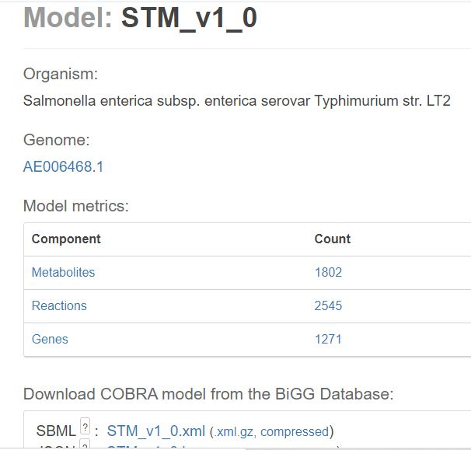

3.From here, we can retrieve the information we require , for example the

* Genes
* Metabolites
* Reactions

**3.1 Genes:**

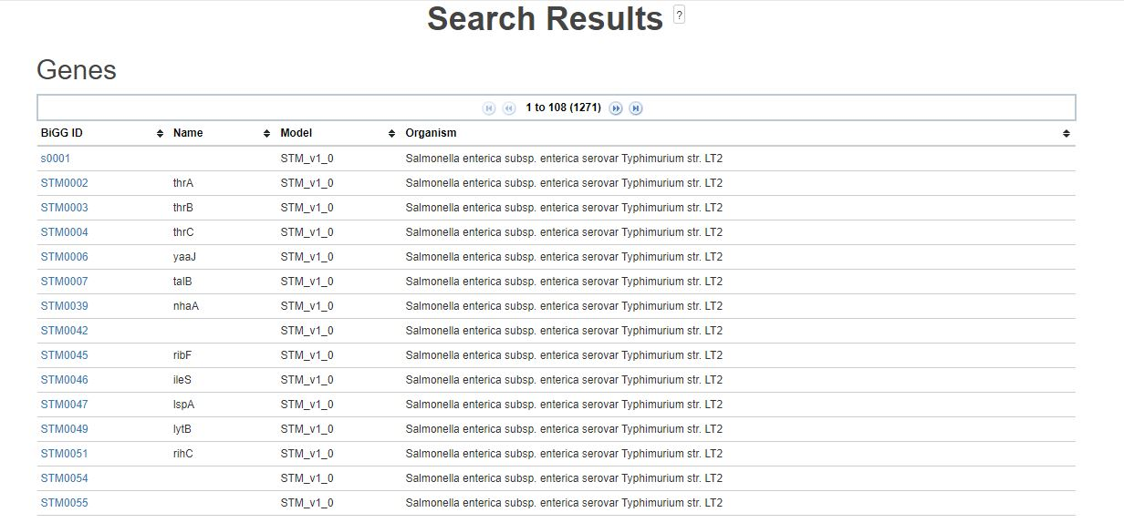

**3.2 Metabolites:**

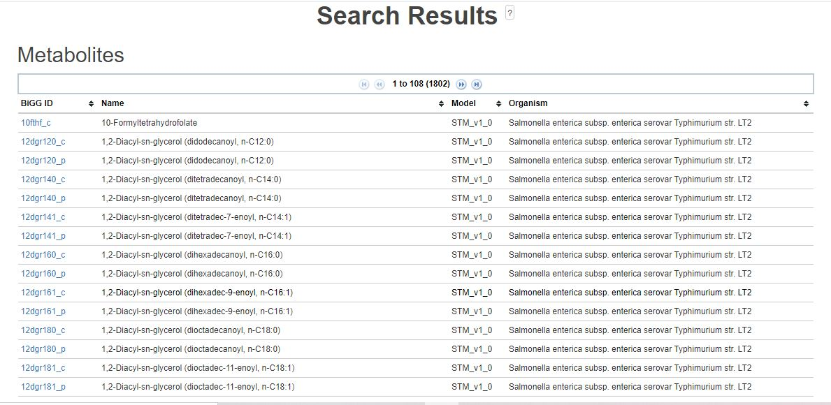

**3.3 Reactions:**

